|  |
| --- |
|  |
|  |
| **Installation Manual**      **SmartMedic**  Stryker Global Technology Center Pvt. Ltd. Vatika Business Park, 10th Floor, Block Two, Sohna – Gurgaon Rd, Sector 49, Gurugram, Haryana, 122002, India  **Manufactured at:**  Plot No. 130, 4th Phase KIADB Industrial Area  Bommasandra- Jigani Link Road, Bangalore, Karnataka 560 099, India  **Marketed and Distributed by:**  Stryker India Pvt. Ltd. India  Customer Care No**.**: 1800 103 8030  Email ID:[service.india@stryker.com](mailto:service.india@stryker.com) |
|  |

|  |  |  |  |  |
| --- | --- | --- | --- | --- |
|  | **Name** | **Title** | **Signature** | **Date** |
| **Document Author** | Ketan Pathak | Design Engineer |  |  |
| **Document Approvers** | Vikram Puri | Project Lead |  |  |

**Table of Contents**

1. Purpose 3

2. Part Checklist 4

3. Installation Process Flow 5

4. Installation Procedure 6

4.1 Admin App Registration 6

4.2 Unboxing The Packaging 8

4.3 Visual Check 9

4.4 Plank preparation 9

4.4.1 Anchoring peg installation 9

4.4.2 Bed Surface preparation 12

4.4.3 Installation of Templates 14

4.4.4 Plank Assembly Over Bed Platform 16

4.4.5 Removal of Templating Tools 16

4.5 Bed side display Attachment 17

4.6 Connections 18

4.6.1 Wire Routing 20

4.7 Mattress Installation 26

4.8 Initial system setup 27

4.8.1 On the Bed Side Display: 27

4.8.2 Tablet Enclosure Preparation: 29

4.8.3 Configuration of SmartMedic Tablet with SmartMedic Device: 30

4.8.4 On the Nurse Station Display: 36

5. Test run 37

6. Discard packaging 37

7. Installation Checklists & Tasks 38

8. Software Version Upgradation 38

8.1 Tablet Application Upgrade 38

8.2 SmartMedic Firmware Upgrade 39

# Purpose

This document is a guide for SmartMedic installation & service activities. The information mentioned in this manual is for basic activities. In case of any troubleshooting or any problem which is not in the scope of this document shall be communicated to Stryker Team at SGTC as per contact details mentioned on the title page.

# Part Checklist

Following are the items that can be referred in case of support or identification.

|  |  |  |  |  |  |
| --- | --- | --- | --- | --- | --- |
| **Items included in SmartMedic package** | | | | | |
| **Item** | | **Part no.** | **Description** | **Quantity** | |
| 1 | | 001-02-A-01-00-00 | Head Plank Assembly | 1 | |
| 6 | | 001-02-A-02-00-00 | Abdomen Plank Assembly | 1 | |
| 7 | | 001-02-A-03-00-00 | Thigh Plank Assembly | 1 | |
| 8 | | 001-02-A-04-00-00 | Foot Plank Assembly | 1 | |
| 11 | | 001-02-A-05-00-00 | Bed side display Assembly | 1 | |
| 12 | | 001-02-E-06-00-00 | Plank to plank cable | 3 | |
| 13 | | 001-02-A-07-00-00 | Power adaptor assembly | 1 | |
| 14 | | 001-02-M-01-12-00 | Anchoring Peg, Bed Side, Type-1 | 16 | |
| 15 | | 001-02-M-01-13-00 | Anchoring Peg, Bed Side, Type-2 | 14 | |
| 16 | | 001-02-A-08-00-00 | X-Ray Tray Assembly | 1 | |
| **Additional Accessories** | | | | | |
| 17 | 001-02-A-09-00-00 | | Gateway Mount Assembly | | 1 |

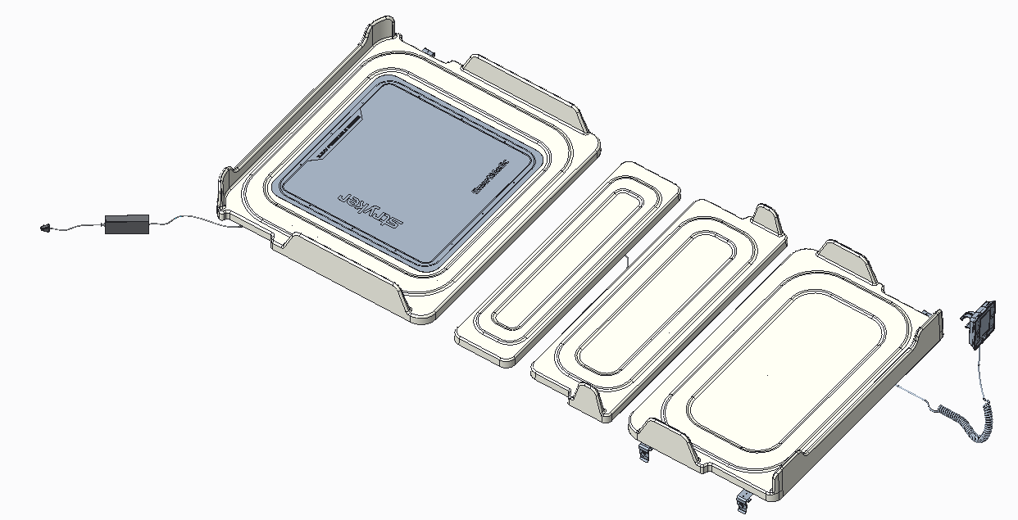

*Fig. 1: SmartMedic Assembly*

# Installation Process Flow

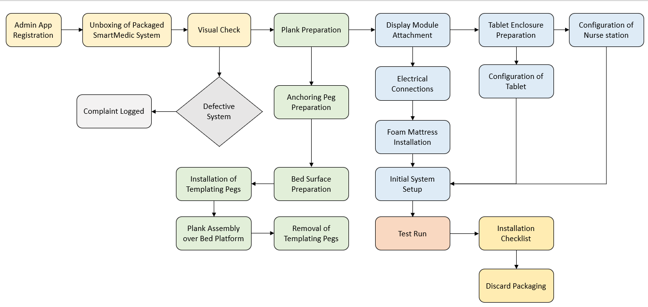

*Fig. 2: Installation Process Flow*

# Installation Procedure

## Admin App Registration

**Step-1:** On the Browser, open the link <https://admin-nursestation.azurewebsites.net/> to initiate the registration. Admin app webpage (See fig. 3) will be opened. Enter the “Email” and “Password” to open the admin app dashboard (See fig. 4).

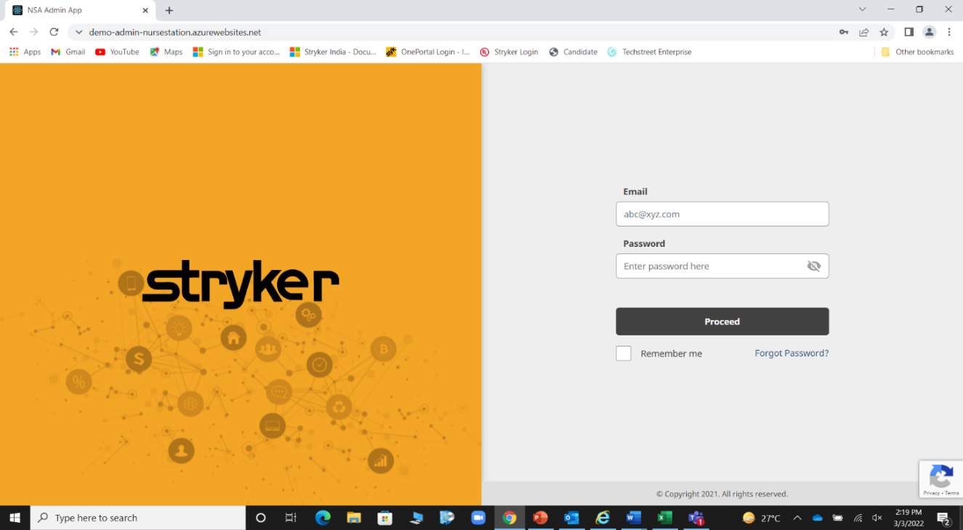

*Fig. 3: Admin App Webpage*

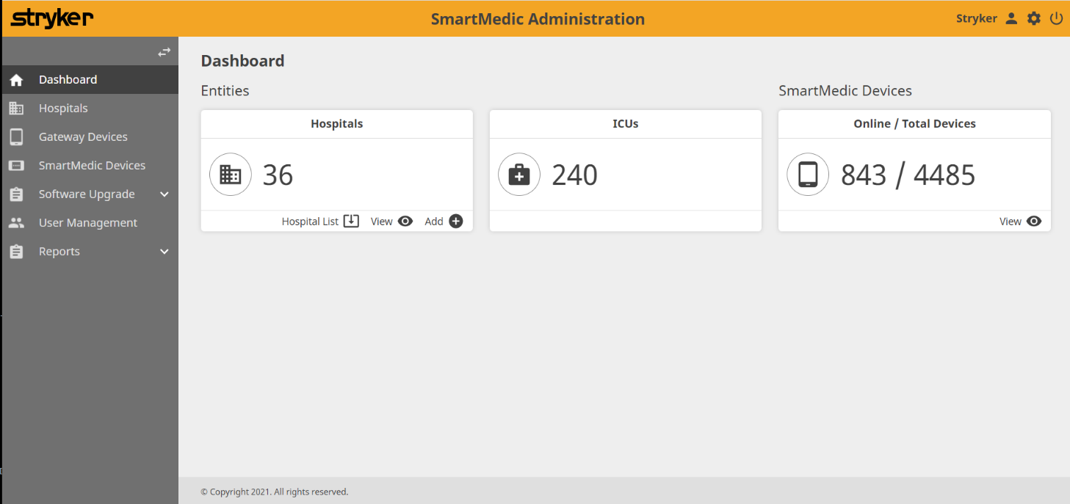

*Fig. 4: Admin App Dashboard*

**Step- 2:** Click on the hospital name (if available) in the list.

OR

Search the hospital name in “Search Bar” (See fig. 5).

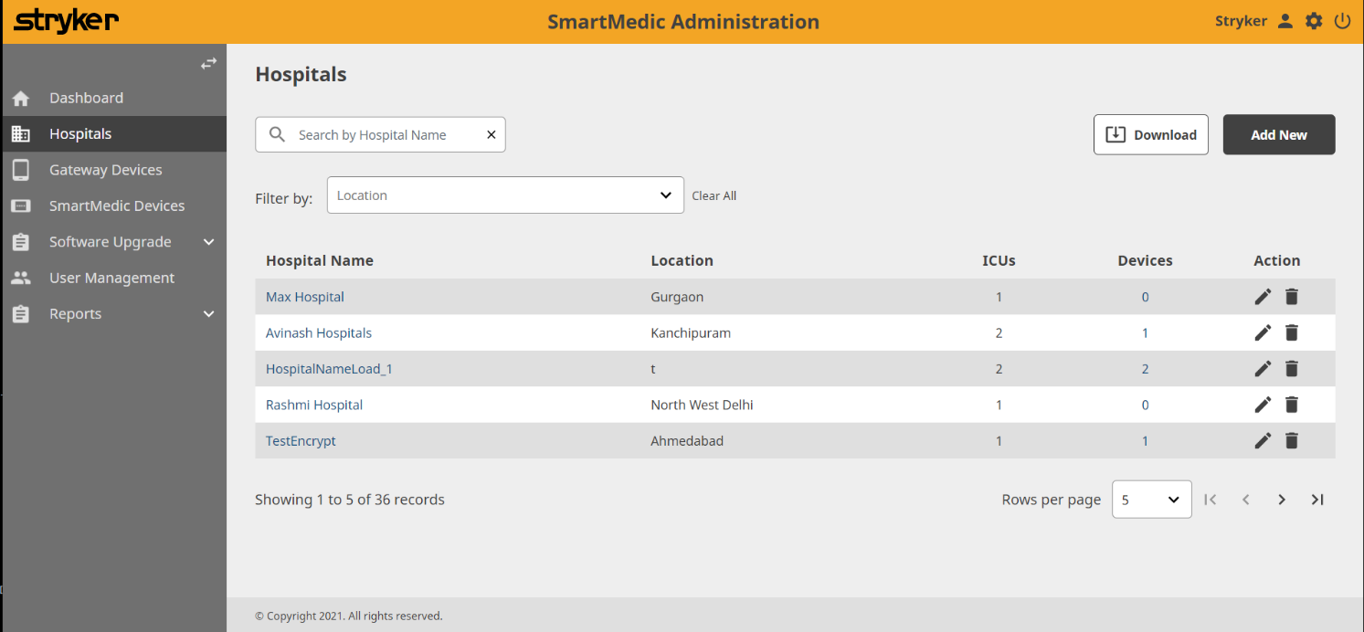

*Fig. 5: Hospital Search Page*

**Step- 3:** After selecting the hospital,webpage (See fig. 6) will open. Fill the details required to generate a hospital code. Note down the code and use this for the nurse station.

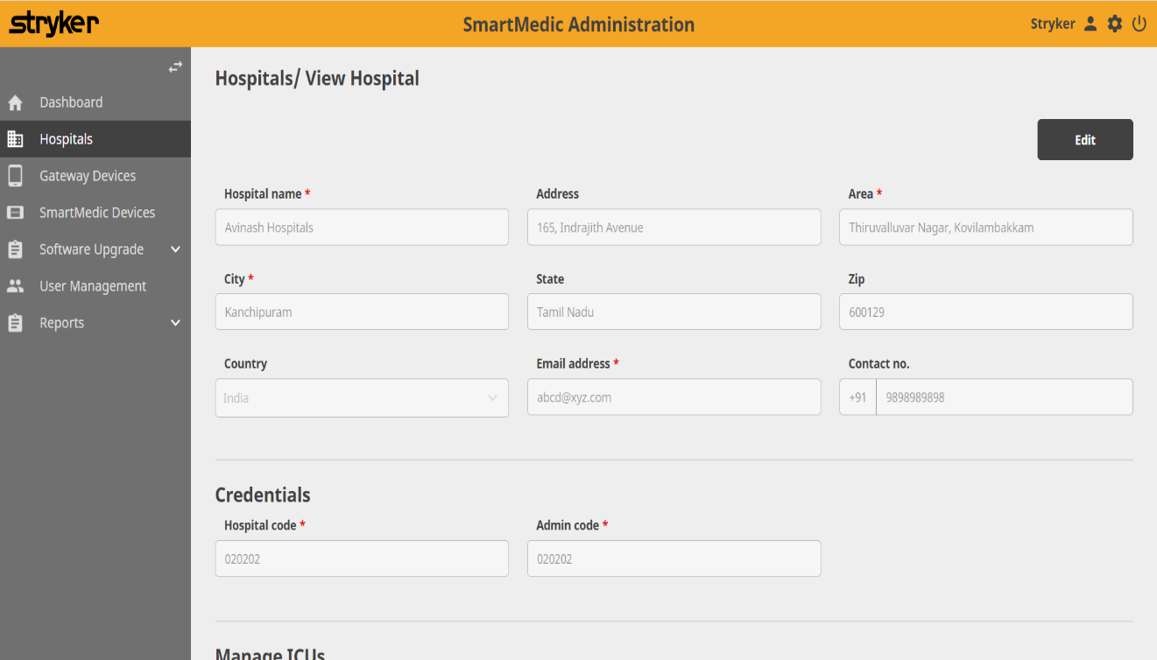

*Fig 6: Hospital Code Generator*

**Step- 4:** After code generation scroll down on the same page. Click “Add ICU” to create the required number of ICU for the respective hospital (See fig. 7).

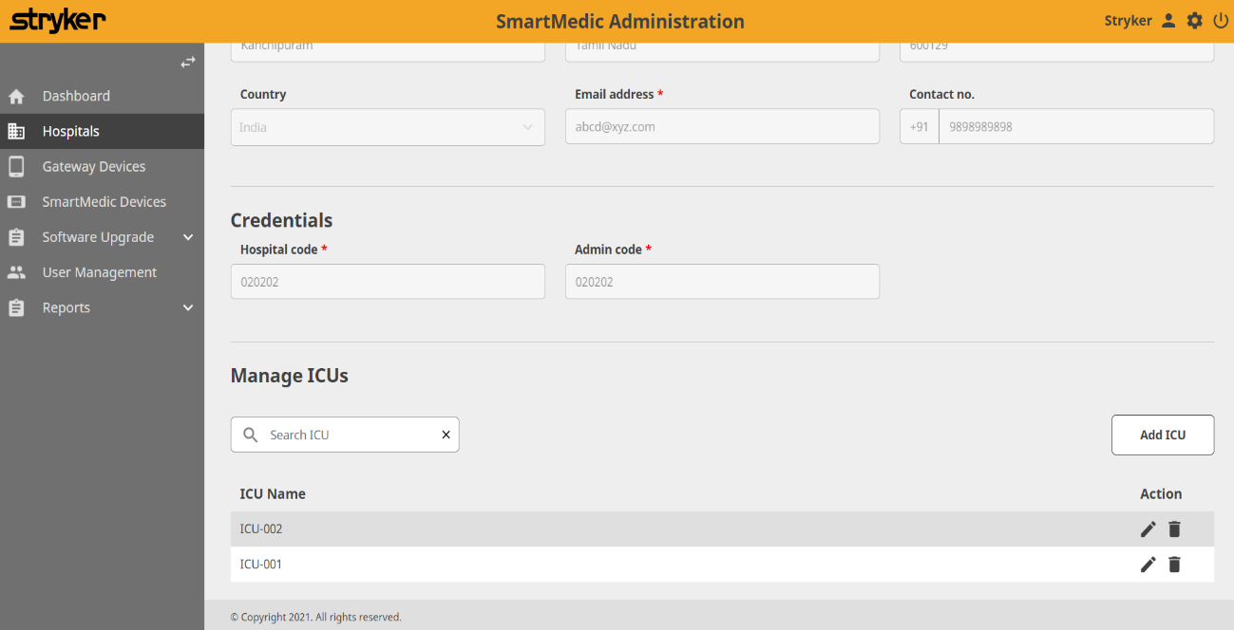

*Fig. 7: ICU Creation*

**Step- 5:** Logout of the admin app.

## Unboxing The Packaging

1. Place the package on the flat platform.
2. Always place the package, keeping the top face (Stryker Logo) up as shown in fig. 8 to avoid any damage due to inversion while unboxing.
3. Cut the plastic packaging straps with a paper cutter.
4. Lift the top cover of the package to access the components placed within it as shown in fig. 9.
5. While unboxing, care must be taken that it should not damage the parts or package kept inside it.
6. Check the part number of the components with list provided to ensure the everything is present in package as shown in fig. 10.
7. Open the component boxes to confirm the part quantity as mentioned in the part checklist.
8. Carefully place the unboxed components before starting the installation.

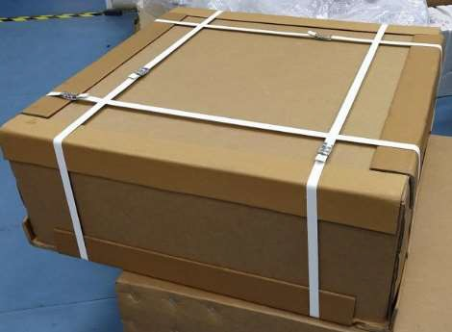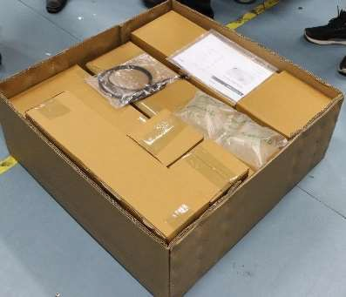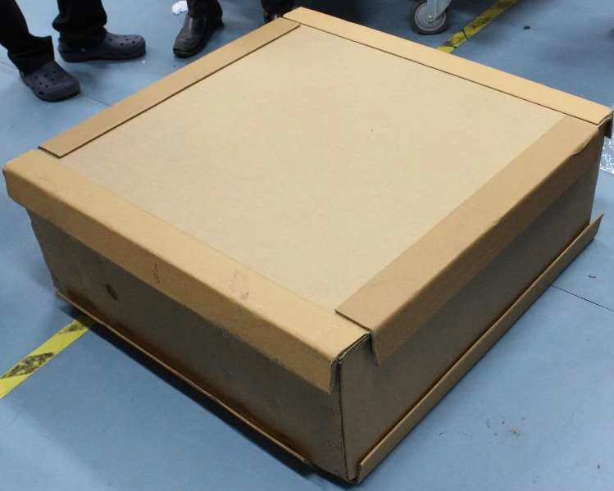

*Fig. 8: System Package Fig. 9: Top Cover of Package Fig. 10: Parts boxes in Package*

## Visual Check

1. Perform a visual check for assuring all the components of the package and the external skin of the package were received as expected.
2. In case of any major damage during shipment, a photo along with description must be shared with service team for approval.

## Plank preparation

### Anchoring peg installation

* + - 1. The anchoring parts are to be installed on the four planks (Head Plank Assembly, Abdomen Plank Assembly, Thigh Plank Assembly & Foot Plank Assembly), therefore, unpack these parts on the flat clean surface along with the Bed side anchoring pegs.
      2. Place the packaged bubble wrap on the floor with individual plank and keep each plank over that bubble wrap to avoid any damage to the plank surface.
      3. Take each plank one at a time to begin the anchoring peg preparation on the bottom of the plank as shown in fig. 11.

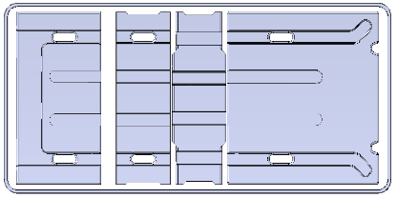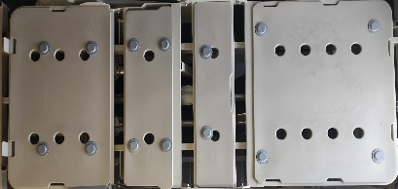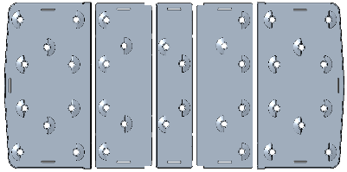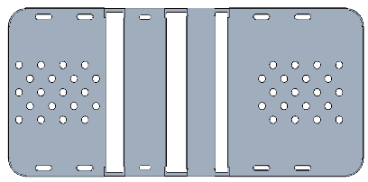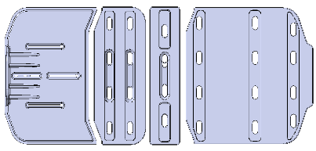

**Sample A Sample B Sample C Sample D Sample E**

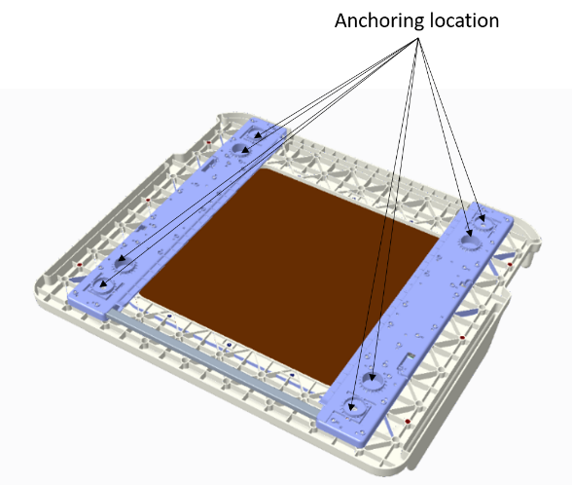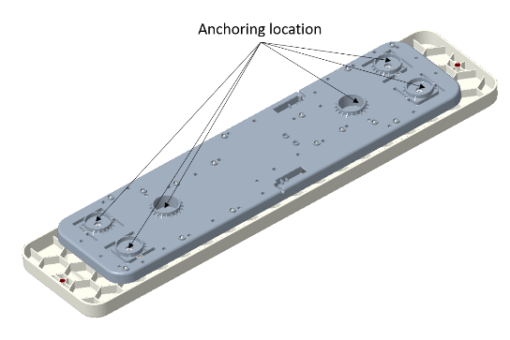

11(a): Head Plank: 001-02-A-01-00-00 11(b): Abdomen Plank: 001-02-A-02-00-00

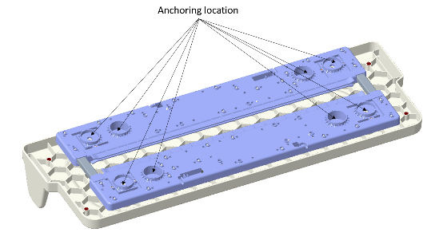 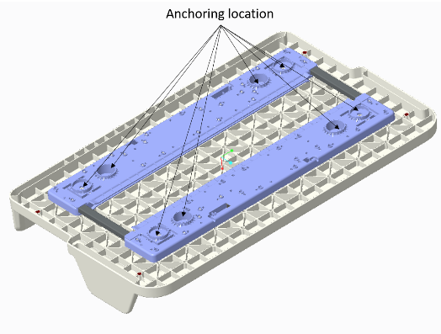

11(c): Thigh Plank: 001-02-A-03-00-00 11(d): Foot Plank: 001-02-A-04-00-00

*Fig. 11: Plank Side Anchoring Positions*

* + - 1. Insert the Bed side anchors (fig. 12) to the bottom side of the plank as shown in fig. 13.

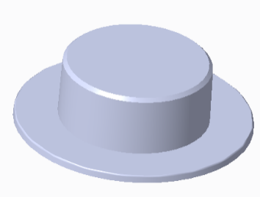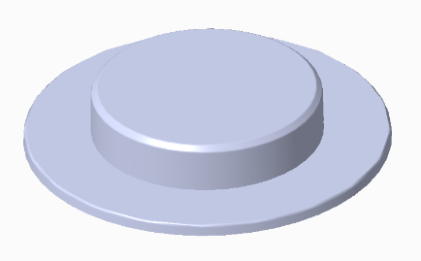

*Fig. 12: Bed Side Anchoring Peg* (001-02-M-01-12-00) and *Bed Side Anchoring Peg* (001-02-M-01-13-00)

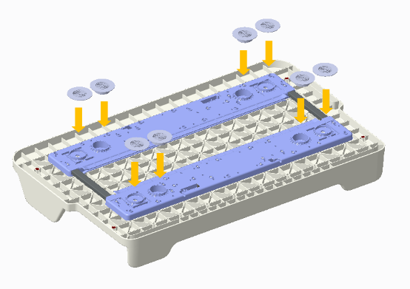

*Fig. 13: Anchoring Assembly on the Plank*

* + - 1. Ensure the anchoring assembly is tightly fit and must not fall due to gravity when plank is inverted.
      2. Each plank will have the anchors in the following quantities:

|  |  |  |  |  |
| --- | --- | --- | --- | --- |
| Head plank | - | 4 + 4 | NOS | (001-02-M-01-12-00) + (001-02-M-01-13-00) |
| Abdomen plank | - | 4 + 2 | NOS | (001-02-M-01-12-00) + (001-02-M-01-13-00) |
| Thigh plank | - | 4 + 4 | NOS | (001-02-M-01-12-00) + (001-02-M-01-13-00) |
| Foot plank | - | 4 + 4 | NOS | (001-02-M-01-12-00) + (001-02-M-01-13-00) |

**Note: The anchors will hold onto planks without any adhesive.**

* + - 1. Follow the same steps as mentioned above for all four planks and keep the planks aside resting on the anchors on the bottom carefully to avoid any damage.

**For Sample E:**

Four types of anchors are to be used while installing the SmartMedic system on the Sample E Bed.

|  |  |  |  |
| --- | --- | --- | --- |
| **Sr. No.** | **Type of Anchor** | **Part No.** | **Parts per unit** |
| 1 | Sample E Anchors Type-1 (Head Top) | TBD | 2 |
| 2 | Sample E Anchors Type-2 (Short All) | TBD | 14 |
| 3 | Sample E Anchors Type-3 (High Head) | TBD | 6 |
| 4 | Sample E Anchors Type-4 (High All) | TBD | 8 |

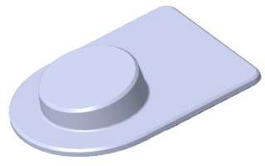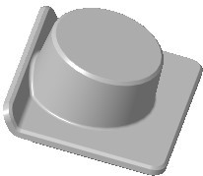

*Fig. 14: Sample E Anchors Type-1 (Head Top) Fig. 15: Sample E Anchors Type-2 (Short All)*

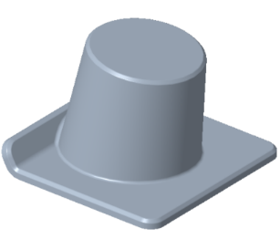

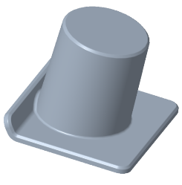

*Fig. 16: Sample E Anchors Type-3 (High Head) Fig. 17: Sample E Anchors Type-4 (High All)*

### Bed Surface preparation

Before installing the device on the bed platform, the surface of the bed should be free from dust, dirt, or other debris so that the anchors can be fixed with maximum adhesion.

Use 3M 94 Primer (see fig. 18) with the micro-fibre cloth to clean dirt or debris.

*Fig.18: 3M Primer & 3M Micro-fibre Cloth*

The bed preparation will be same for all the beds except ***Sample A*** bed platform in which additional steps need to be performed as mentioned below:

* + - 1. **Bed Platform – Sample A**
         1. To begin with installation, assemble the Stryker spacers provided in the installation kit [001-02-G-00-00-00] over the bed platform. For installation on one ***Sample A*** bed, total 8 NOS of spacers as shown in fig. 19(a) & 19(c) will be needed.
         2. Insert the spacers 4 NOS on Head Side region and the Thigh Side region as shown in fig 19(a).
         3. Ensure all 8 supports are fixed at the desired locations as they need to be held tightly on the bed platform to hold the anchors when device is installed over the bed surface as shown in fig. 19(b).

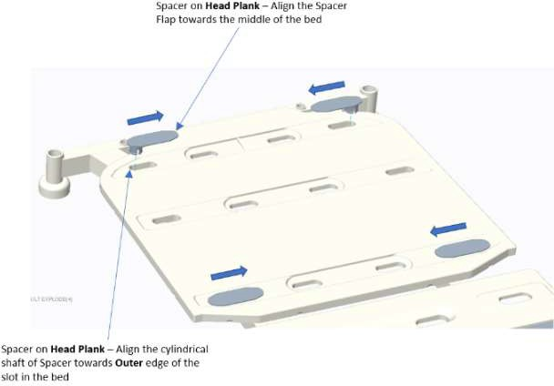

*Fig. 19(a): Position on Bed surface (Head Region)*

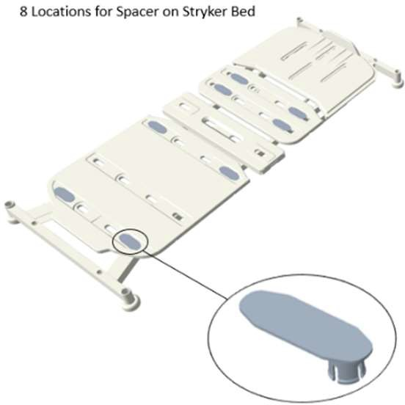 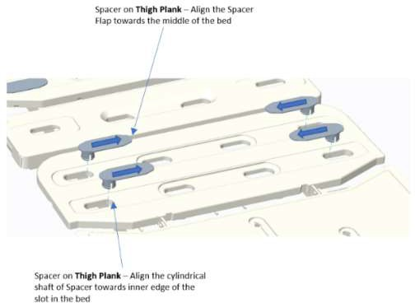

*Fig. 19(b): Spacer Orientation Fig. 19(c): Position on Bed surface (Thigh Region)*

*Fig. 19: Spacer locations on* ***Sample A*** *bed platform*

* + - * 1. Identify the positions on the bed where Bed side Anchors must be pasted.
        2. Before proceeding with the final installation, clean the bed surface with 3M 94 Primer to enhance the adhesion and to remove any debris over the surface.
        3. Attach Templates provided within the installation kit [001-02-G-00-00-00].

### Installation of Templates

|  |  |  |  |
| --- | --- | --- | --- |
|  | **SmartMedic System** | | |
|  | **Sample B** | **Sample C** | **Sample A** |
| **Plank** | **Gap (mm)** | **Gap (mm)** | **Gap (mm)** |
| Headboard to Head Plank | 10 | 9 | 10 |
| Head-Abdomen Plank | 89.6 | 86.5 | 79.5 |
| Abdomen Plank-Thigh Plank | 28.6 | 59 | 55 |
| Thigh Plank-Foot Plank | 25 | 50 | 29.9 |

*Table for Gaps*

**Head Plank templating tool installation**

Assemble “Width Alignment” Template and “Headboard & Footboard (H/F)” Template as shown below. Location for fixing template on the plank depends on the bed on which it needs to be installed. (**Refer Table for Gaps for details**)

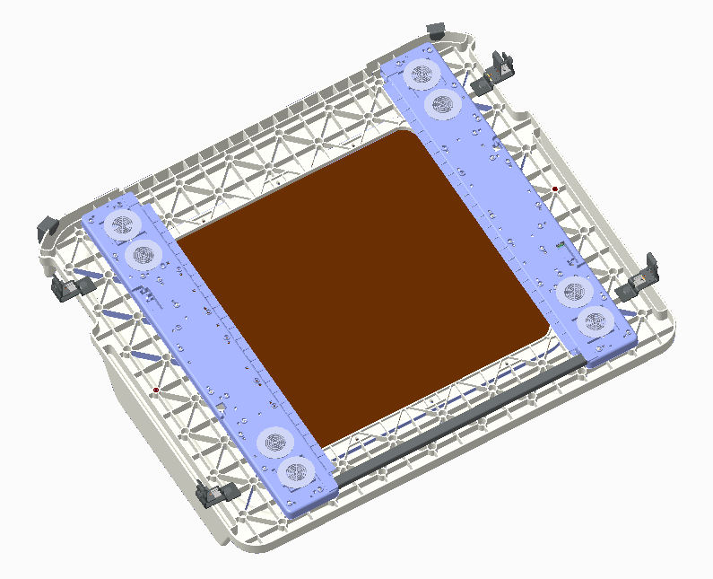

a

b

*Fig. 20: Head Plank Templating*

|  |  |
| --- | --- |
|  | a) 001-02-G-01-00-00, Template, Width Alignment |
|  | b) 001-02-G-03-00-00, Template, Board (H/F) Alignment |

**Abdomen plank templating tool installation:**

Abdomen plank shall be aligned in line with head plank once head plank is installed.

Gap between the planks is adjusted using Gap Control Template as shown in table below.

c

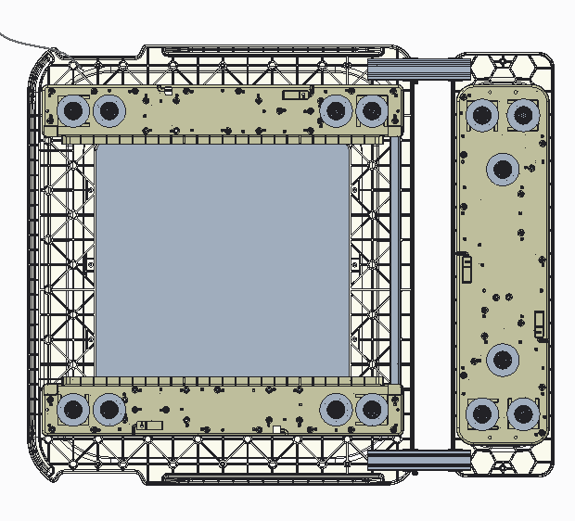

*Fig. 21: Abdomen Plank Templating*

|  |  |
| --- | --- |
|  | c) 001-02-G-02-00-00, Template, Gap Alignment |

**Note: Foot Plank to be installed first for later aligning the Thigh plank**

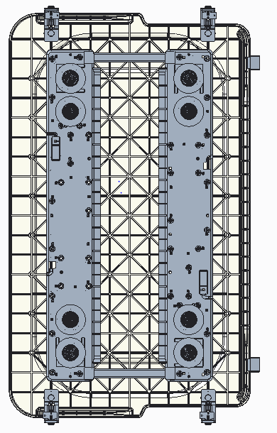**Foot plank template:**

The installation of Templating tools shall be done as per the fig. 22.

The Templating tool needs to be adjusted as per the bed width.

**Thigh plank template**

Thigh plank shall be installed aligning with foot plank and gap (See Table for Gaps) between Foot plank and Thigh plank shall be controlled by setting the Templating tool for Gap control.

*With templating on planks completed, the remaining procedure for* ***Bed preparation*** *can be done.*

*Fig. 22: Foot Plank Templating*

### Plank Assembly Over Bed Platform

* + - * 1. Place the plank on bed along with anchoring pegs and templating parts.
        2. Locate the planks properly using templating parts attached for width alignment. Control the gaps (See Table for gaps) using templating tool for gaps.
        3. Remove the liner from the adhesive tapes of at least four anchors and keep the plank on bed as located. Once these anchors are fixed to the bed, repeat the same with remaining anchors.

### Removal of Templating Tools

* + - * 1. Remove the templating tools after placing the planks over bed platform.
        2. Collect back all the templating tools after installation is complete.

## Bed side display Attachment

1. Take out the bed side display (001-02-A-05-00-00) from the package. Mount the module on to the footboard of the bed. (See fig. 23)

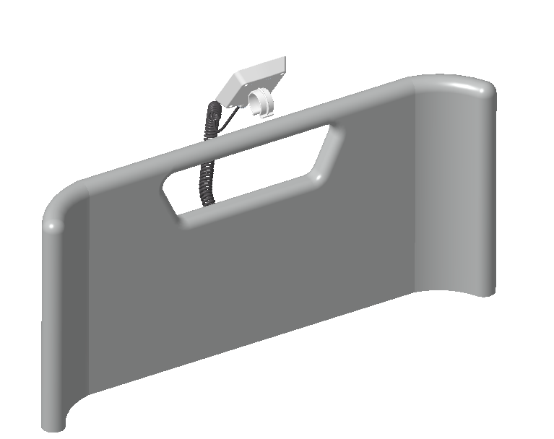

*Fig. 23: Bed side display Assembly on Foot Board*

1. After completion of plank preparation & Bed preparation, connect the Bed side display to the outer end (towards footboard) of Foot plank (see fig. 24)

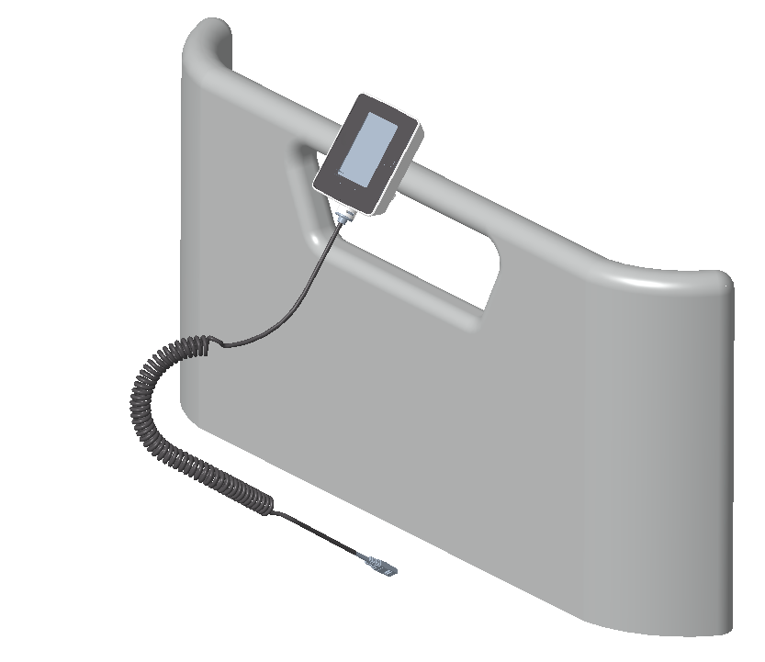

*Fig. 24: Bed side display Assembly*

1. When connected, secure the cable at the foot plank end through the strain relief.
2. Route the spiral cable through underside of the footboard to avoid any damage on the cable. (See fig. 25).

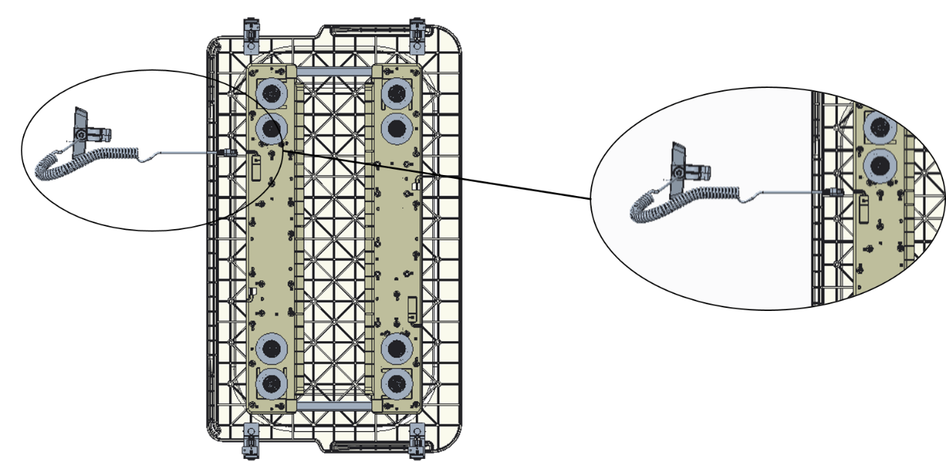

*Fig. 25: Bed side display Cable Routing & Connection*

## Connections

When package has been opened, it contains two types of cables:

* Power Adaptor & Power Cable : 1 qty : Fig. 26: (001-02-A-05-04-00)
* Plank to Plank Cables : 3 qty : Fig. 27: (001-02-E-06-00-00)

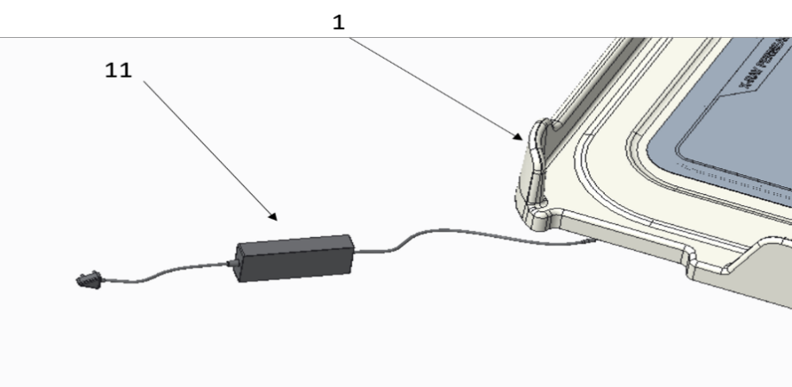

*Fig. 26: Power Adaptor & Power Cable Assembly*

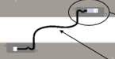

*Fig. 27: Plank to Plank Cable*

1. Attach the power cable on the side of Head Plank at the slot available where the counter must be hanging (towards top left edge). (See fig. 26)
2. Insert the other part of power cable into the power adaptor (see fig. 26). But ensure the socket must not be plugged into the supply before complete connection assembly.
3. Every plank has strain reliefs on the bottom planks at the lower middle edge. It contains connectors for P2P cable (see fig. 27).
4. Make plank to plank connections from:

Head Plank > Abdomen Plank > Thigh Plank > Foot Plank by using P2P cables.

1. Head Plank has only one P2P connection slot while remaining all the planks have two slots on the upper & lower edge on the bottom plank as shown in fig. 28.
2. Ensure that the cable is properly seated within the strain relief (see fig. 28).
3. Switch ON the supply to ensure the device is working by checking the Bed side display.

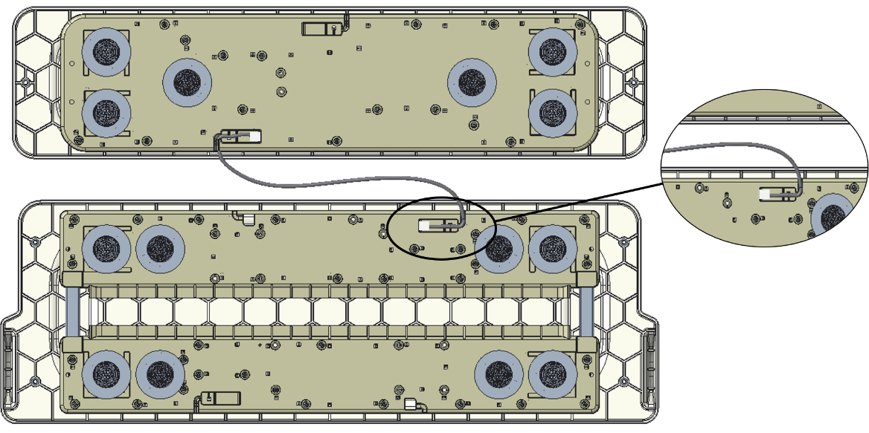

*Fig. 28: Plank to Plank Cable Routing & Connection*

The power adaptor must be attached to the bed frame under the Headboard with the help of routing ties and wire must be attached in a defined path to the rigid frame of bed using routing ties provided within the installation kit.

### 4.6.1 Wire Routing

**NOTE: The images attached below are clicked from Head Plank side.**

**Represents Datum Point -**

**For Sample A Bed****:**

1. Angulate the bed to the maximum angle (as shown in fig. 29(a)).
2. As described in fig. 29(b) locate the datum point (0 cm) i.e., rubber bush side on the headboard base frame and then fix the adaptor in the left direction at a distance of 3 cm using routing ties. Also, adjust the path of wire as shown.
3. At a distance of 42 cm from the datum point, fix the wire to the rigid frame of bed using a routing tie (as shown in fig. 29(b)).
4. As described in fig. 29(c), locate the datum point (0 cm) on the head plank and then at a distance of 12 cm from it fix the wire using a routing tie to the rigid bed frame.
5. Next, tie the wire to the CPR wire of the bed using a routing tie as described in fig. 29(c).
6. Carefully connect the two ends of connector in order to power the SmartMedic device.

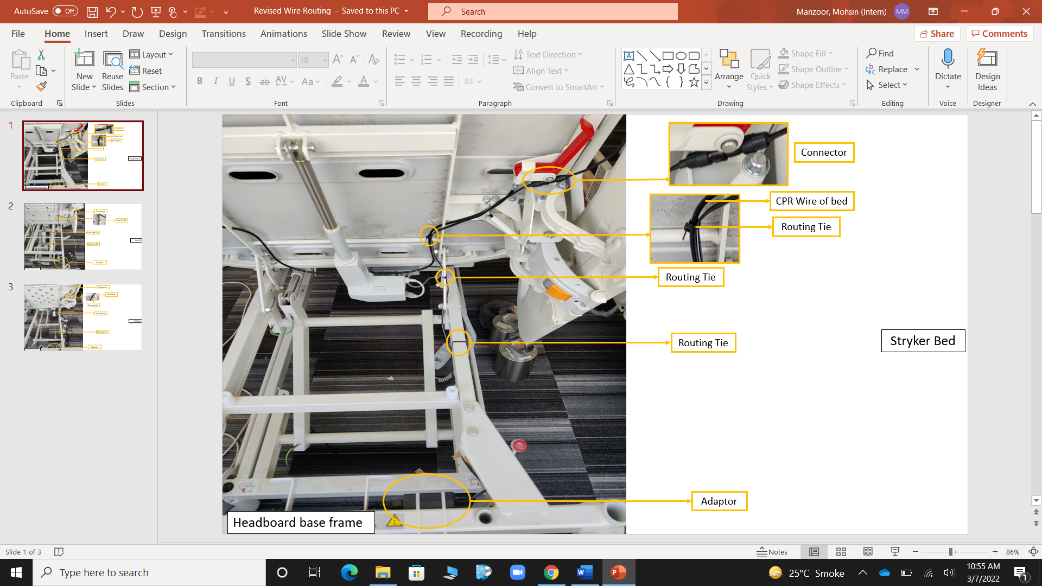

*Fig. 29(a): Sample A bed wire routing*

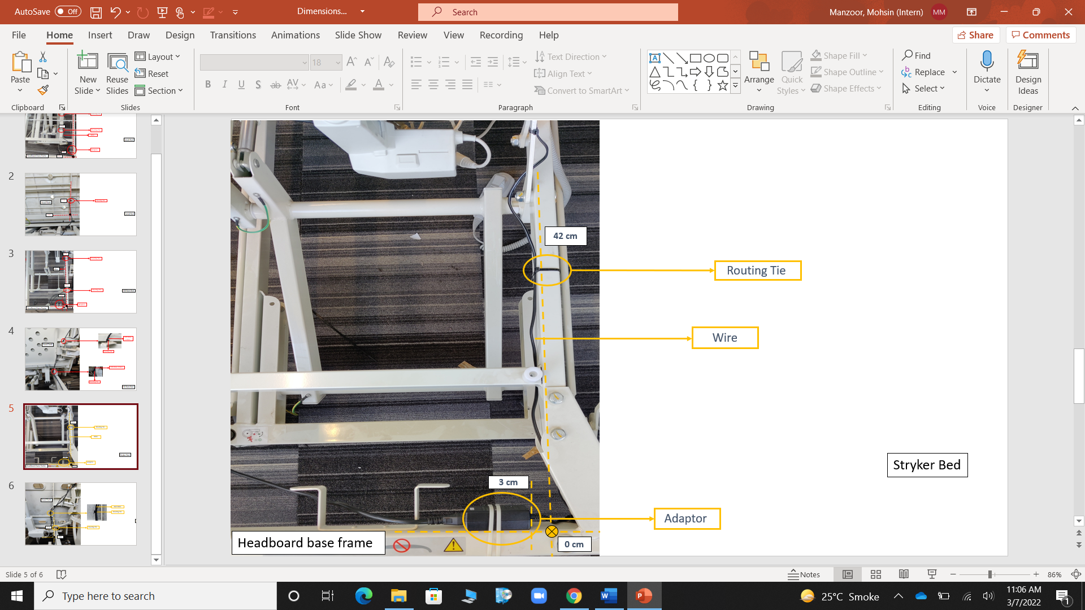

*Fig. 29(b): Wire routing dimensions*

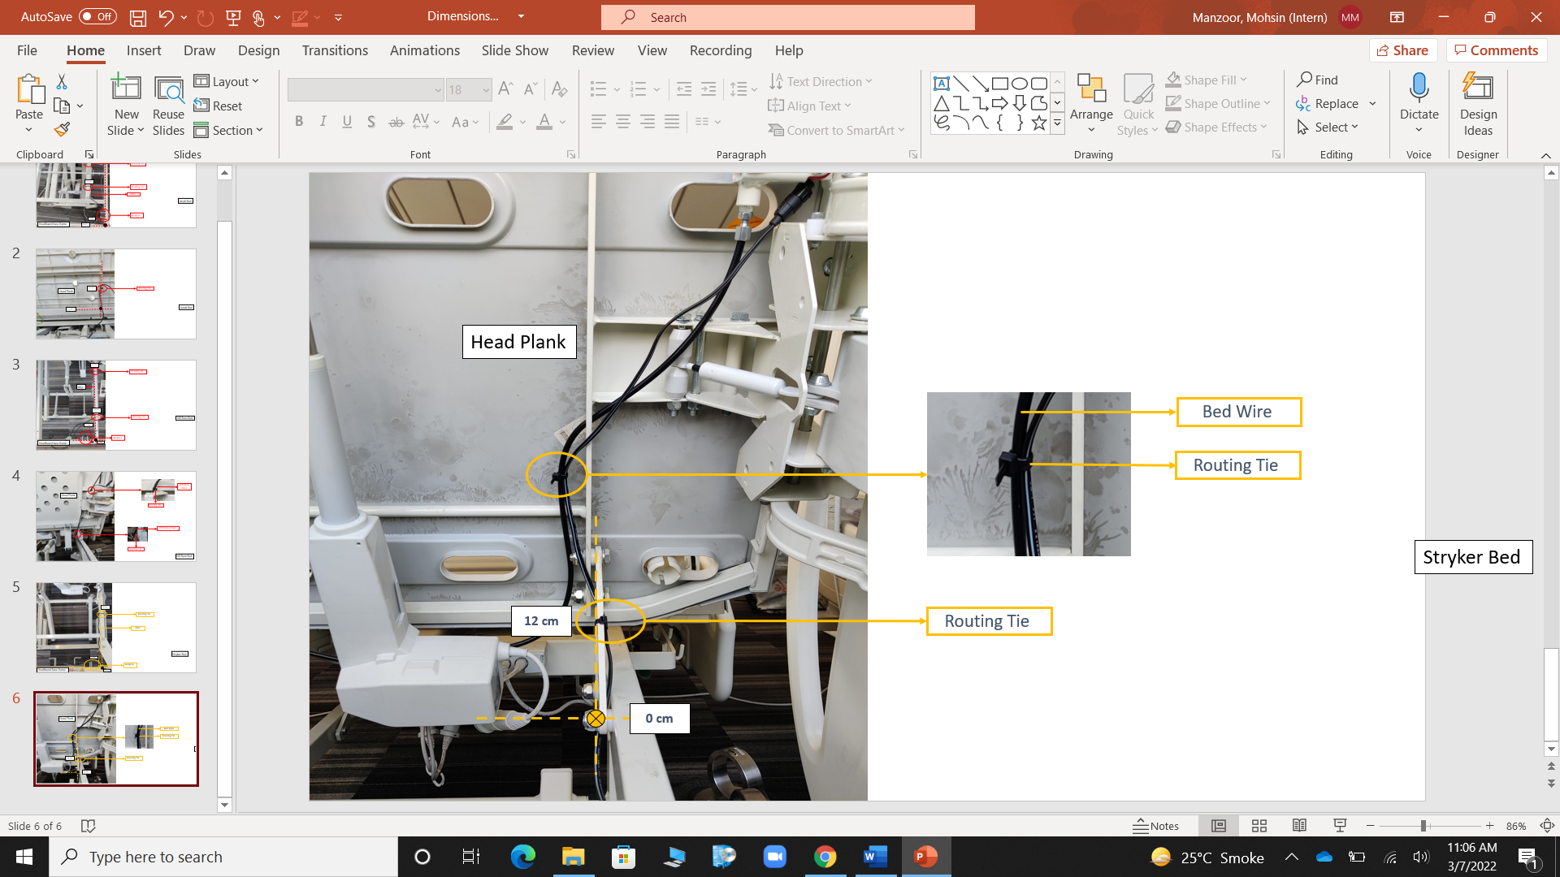

*Fig. 29(c): Wire routing dimensions*

**For Sample B B****ed:**

1. Angulate the bed to the maximum angle (as shown in fig. 30(a)).
2. As described in fig. 30(b) locate the datum point (0 cm) on the headboard base frame and then fix the adaptor at a distance of 6 cm using routing ties. Also, adjust the path of wire as shown.
3. At a distance of 37 cm and 64 cm from the datum point fix the wire to the rigid frame of bed using routing ties (as shown in fig. 30(b)).
4. As described in fig. 30(c), locate the datum point (0 cm) on the head plank and then at a distance of 12 cm from it fix the wire using a routing tie to the rigid bed frame.
5. Carefully connect the two ends of connector in order to power the SmartMedic device.

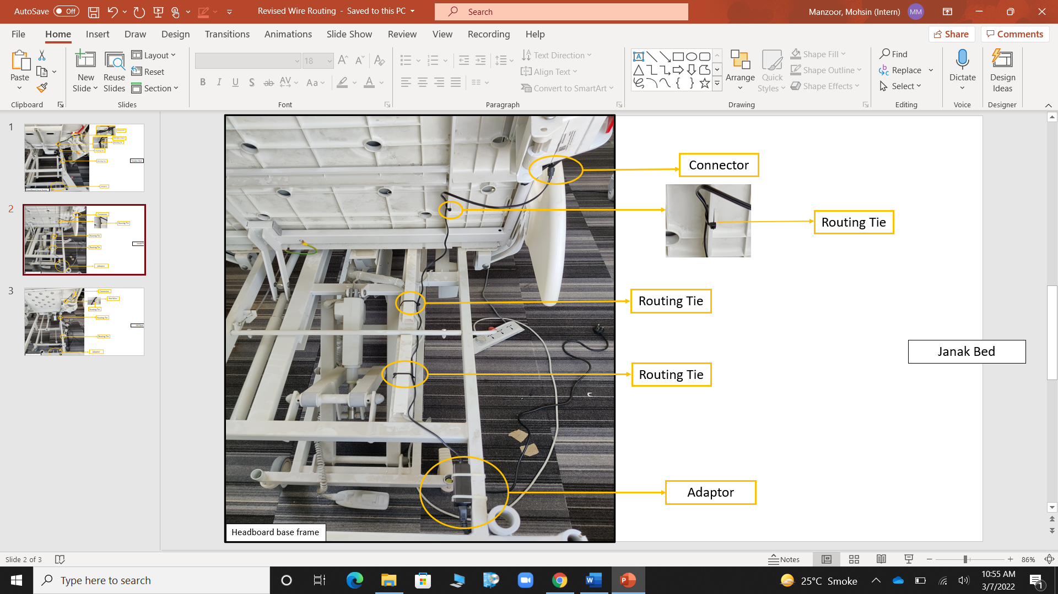

*Fig. 30(a): Sample B bed wire routing*

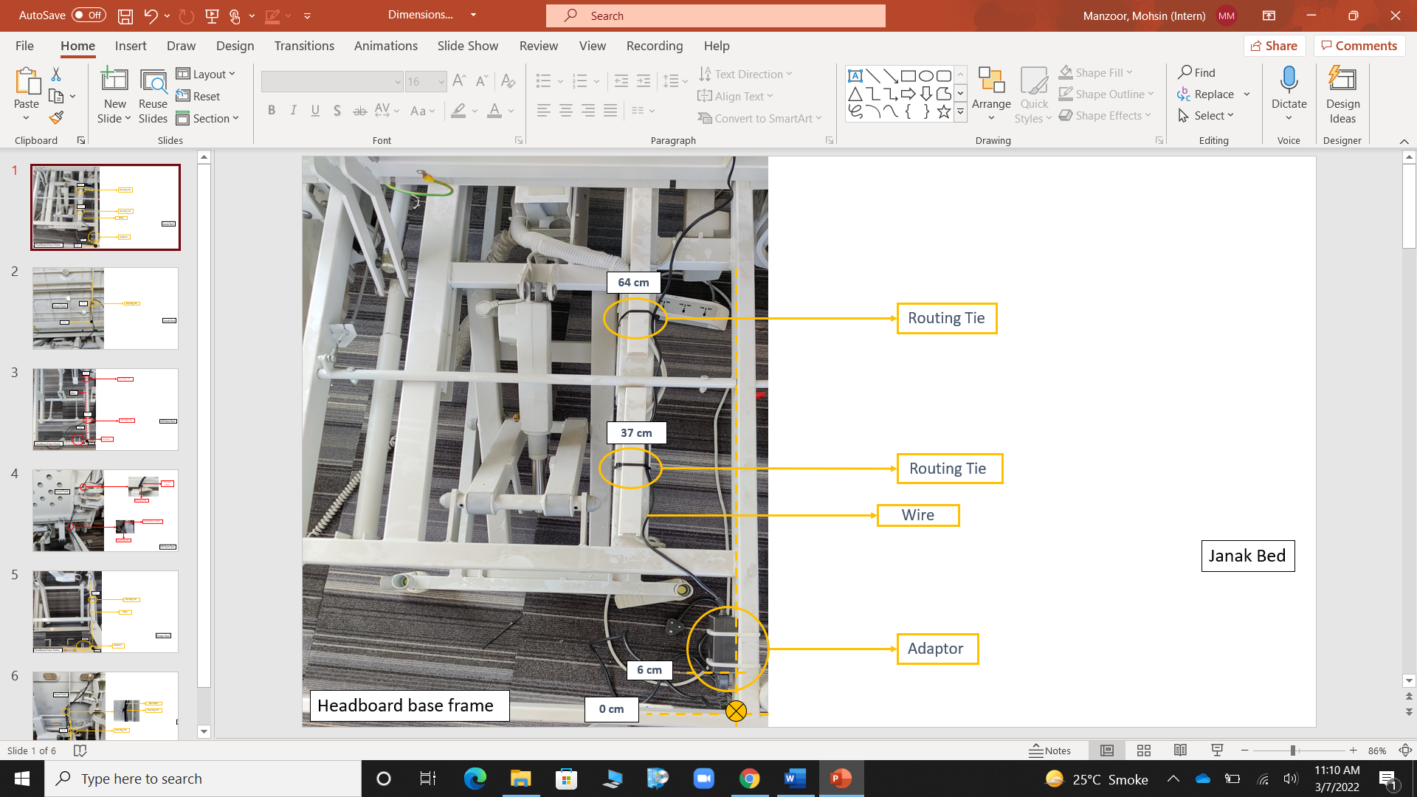

*Fig. 30(b): Wire routing dimensions*

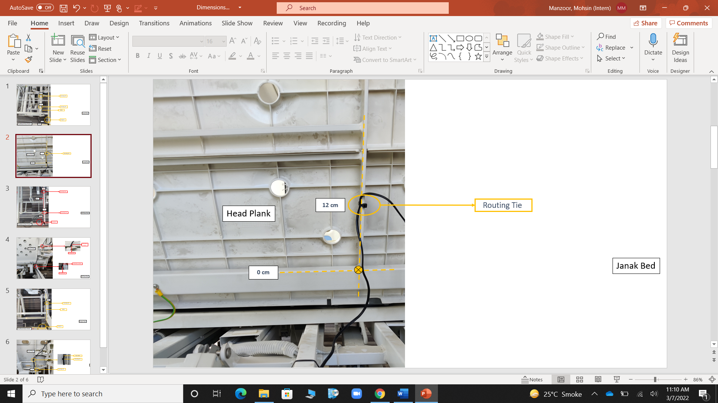

*Fig. 30(c): Wire routing dimensions*

**For Sample C Bed:**

1. Angulate the bed to the maximum angle (as shown in fig. 31(a)).
2. As described in fig. 31(b) locate the datum point (0 cm) on the headboard base frame and then fix the adaptor in left direction at a distance of 5 cm using routing ties. Also, adjust the path of wire as shown.
3. At a distance of 24 cm and 72 cm from the datum point fix the wire to the rigid frame of bed using routing ties (as shown in fig. 31(b)).
4. As described in Figure C, tie the wire to the CPR wire of the bed using routing ties.
5. Carefully connect the two ends of connector in order to power the SmartMedic device.

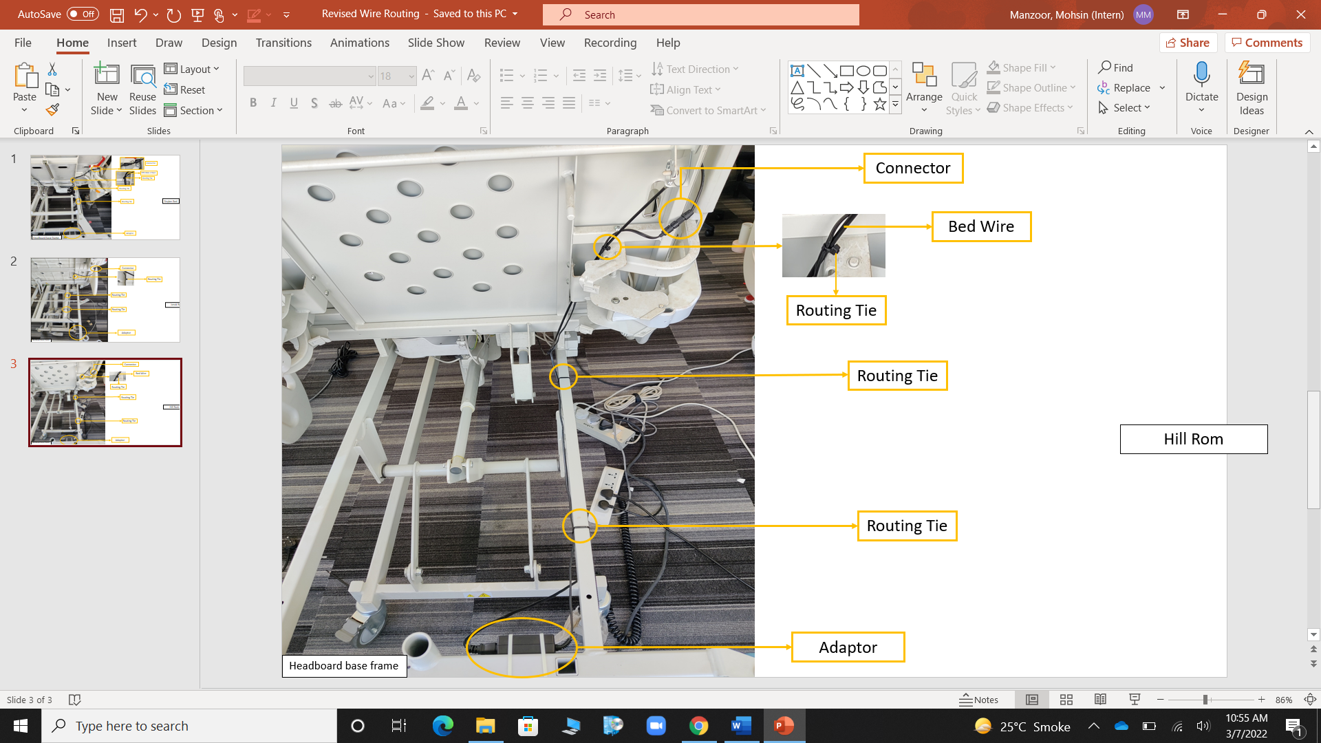

*Fig. 31(a): Sample C bed wire routing*

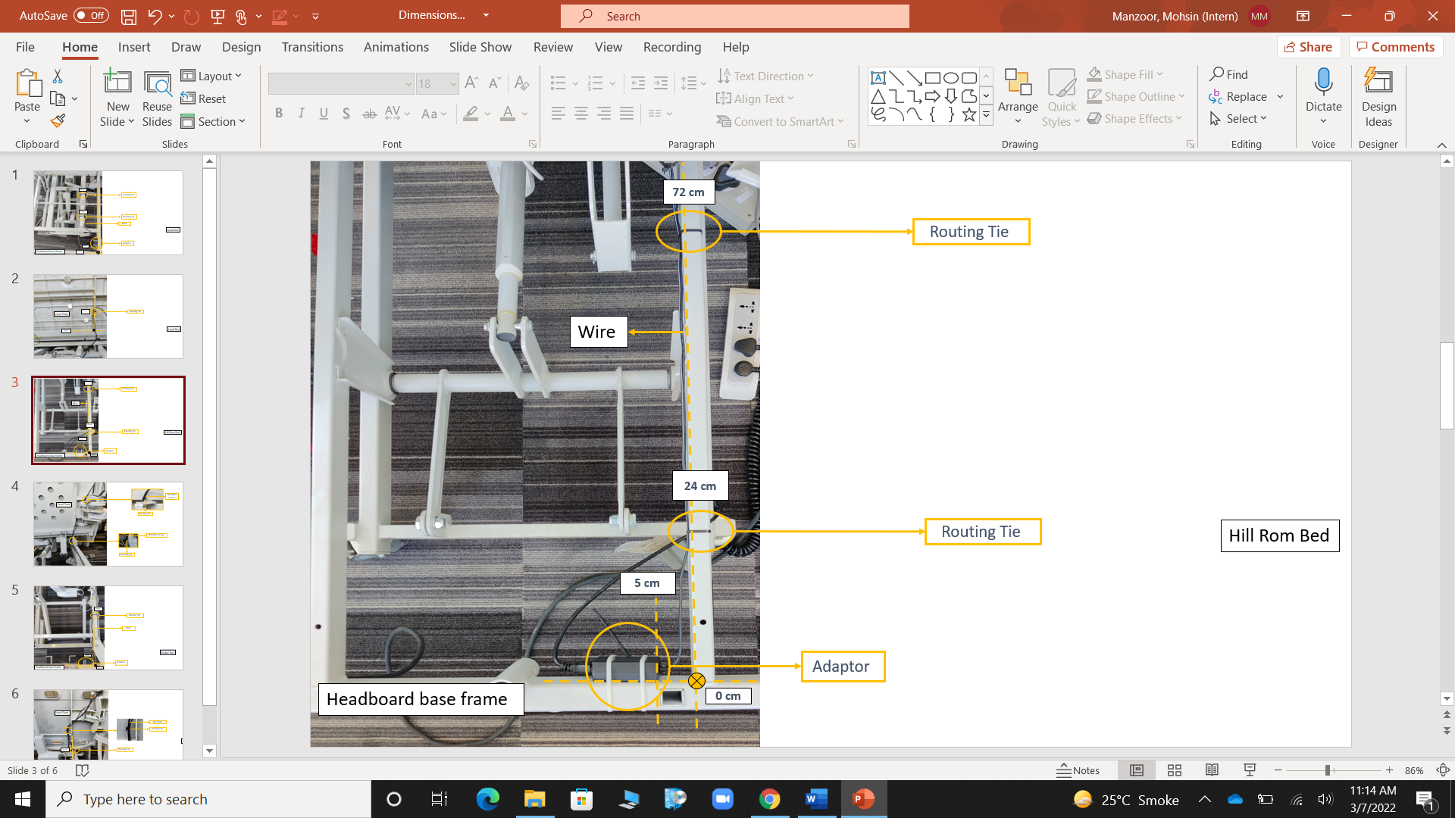

*Fig. 31(b): Wire routing dimensions*

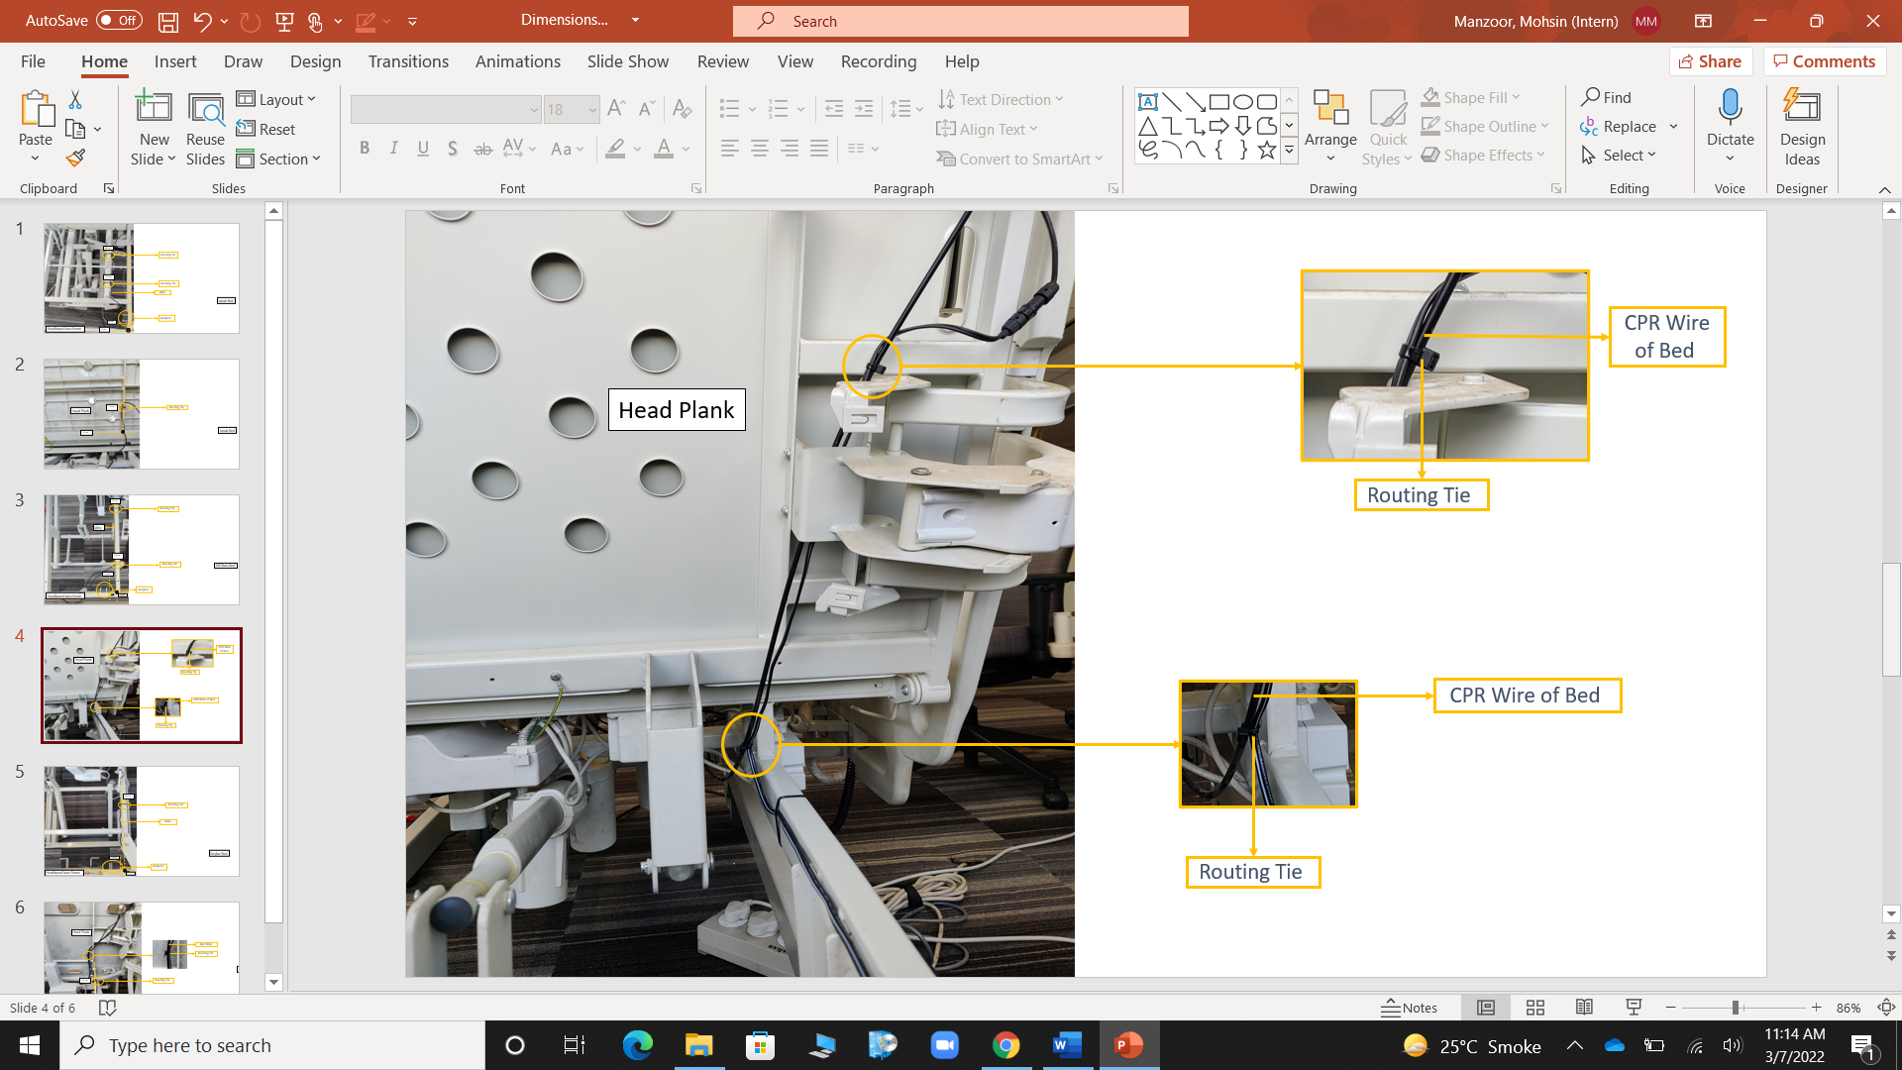

*Fig. 31(c): Wire routing dimension*

**For Sample D Bed:**

1. Angulate the bed to the maximum angle (as shown in Figure 32).
2. As described in Figure 32 locate the datum point (0 cm) on the headboard base frame and then fix the adapter in the left direction at a distance of 23.5 cm using routing ties. Also, adjust the path of wire as shown.
3. At a distance of 14.5 cm from the datum point, fix the wire to the rigid frame of bed using a routing tie (as shown in Figure 32).
4. Next, at a distance of 62 cm from the datum point, fix the wire to the rigid frame of bed using a routing tie (as shown in Figure 32).
5. Carefully connect the two ends of connector in order to power the SmartMedic System.

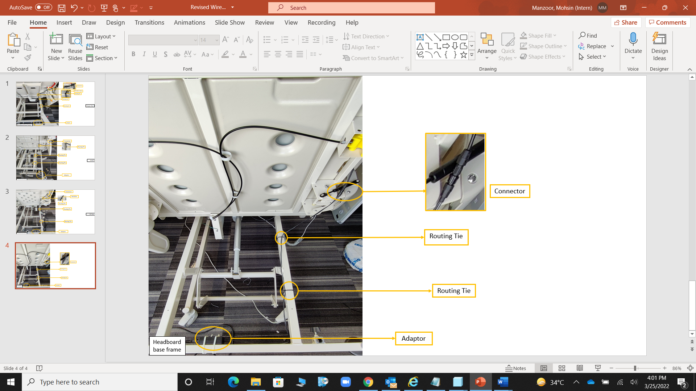

*Fig. 32(a): Sample D bed wire routing*

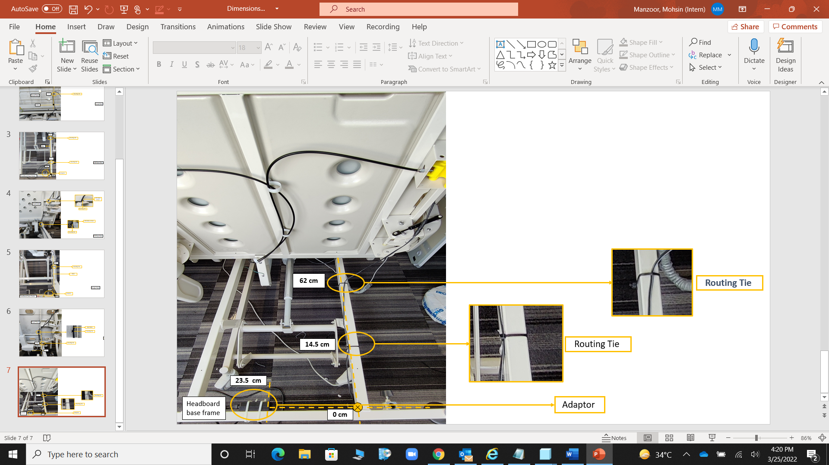

*Fig. 32(b): Wire routing dimensions*

**For Sample D Bed:**

1. Angulate the bed to the maximum angle (as shown in Figure 33).
2. As described in Figure 33, locate the datum point (0 cm) on the headboard base frame and then fix the adapter in the right direction at a distance of 3.5 cm using routing ties. Also, adjust the path of wire as shown.
3. At a distance of 38 cm from the datum point, fix the wire to the rigid frame of bed using a routing tie (as shown in Figure 33).
4. Next, at the hinge point fix the wire using a routing tie to the rigid head frame (as shown in Figure 33).
5. At a distance of 46 cm from the hinge point fix the wire to the rigid head frame using another routing tie (as shown in Figure 33).
6. Carefully connect the two ends of connector in order to power the SmartMedic System.

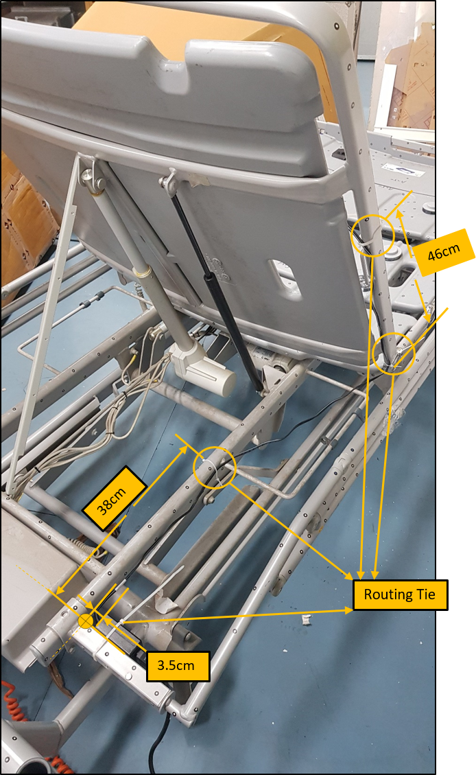

*Fig. 33: Wire routing dimensions for Sample E*

## Mattress Installation

Device must be installed with Stryker Foam Mattress (see fig. 34).

The device will be handed over to the customer after installing with the above-mentioned mattress.

When all the electric connections are completed and system is up and running, then perform the following steps for the mattress used:

**For Foam Mattress:**

1. Unpack the foam mattress box with the use of a paper cutter. But care must be taken to avoid any damage to the mattress.
2. Handle the mattress carefully and keep the top side of the mattress towards the face while lifting (see fig. 34). Top surface can be identified by observing the zip cover, as it must always be down with respect to this orientation.
3. Insert the mattress from the Head side mattress support.
4. Press the mattress with slight force from the top, to ensure that the mattress is constrained within the space defined by the mattress supports.
5. Inspect the periphery of the device to ensure that no part of the mattress is touching the bed accessory. If any, rectify the same and if unable to do so, then connect with the Stryker team & mention the same in installation checklist.

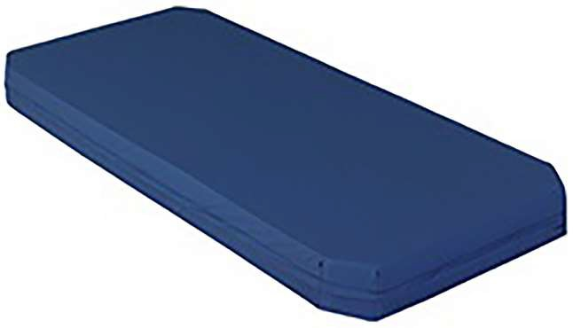

*Fig. 34: Foam Mattress*

## Initial system setup

Ensure the bed is flat and horizontal and when the device is powered ON the Bed side display will have specific screens where information needs to be added for initiating the system. Following steps need to be performed:

### 4.8.1 On the Bed Side Display:

**Step- 1:** When power is ON, Stryker logo will appear on the Bed side display screen.



*Fig. 35: Stryker Logo Screen*

**Step- 2:** After Stryker logo, the display will automatically change to another screen, for that patient must not be on the bed.

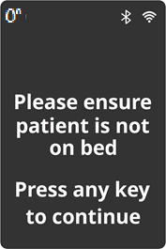

*Fig. 36: Tare prompt screen*

**Step- 3:** Press any key to start taring and then screen will navigate to System taring in progress screen.

.

*Fig. 37: System taring in progress Screen*

**Step- 4:** This screen must time out after Taring calculation is complete. After Taring, the screen must display “Tare successful” screen.

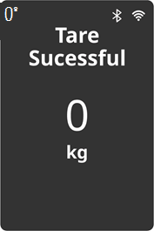

*Fig. 38: Tare successful Screen*

**Step- 5:** Tare successful screen with post tare weight in Kg will be displayed. Pressing any key must display Get weight screen.



*Fig. 39: Get weight Screen*

### 4.8.2 Tablet Enclosure Preparation:

1. Locate a suitable place for the tablet enclosure and for the charger of tablet.
2. Remove the liner from the dual lock tape of the enclosure and fix it on the suitable location.
3. Insert the charging Micro-USB in the enclosure and place the tablet inside the enclosure connected to the same.
4. Lock the enclosure by the screws provided (using provided tool).

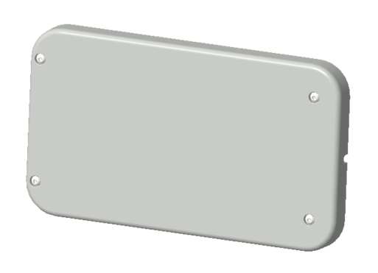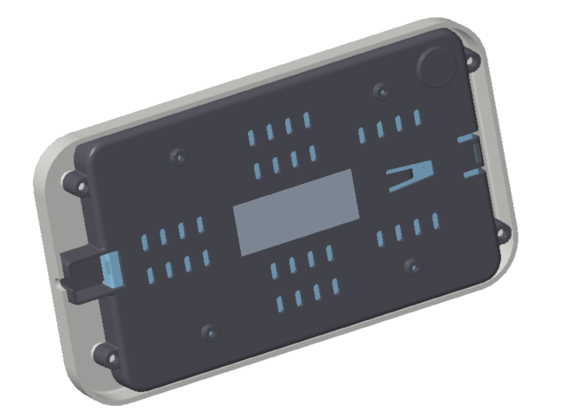

*Fig. 40: Tablet (Gateway) Enclosure*

### 4.8.3 Configuration of SmartMedic Tablet with SmartMedic Device:

1. The SmartMedic device should be powered ON and connected to the specified bed.
2. The SmartMedic tablet should be powered ON, and the latest build should be installed on the tablet.
3. Click on the check box named "I agreed the terms and conditions" and the "Proceed" button on the tablet screen (See fig. 41).

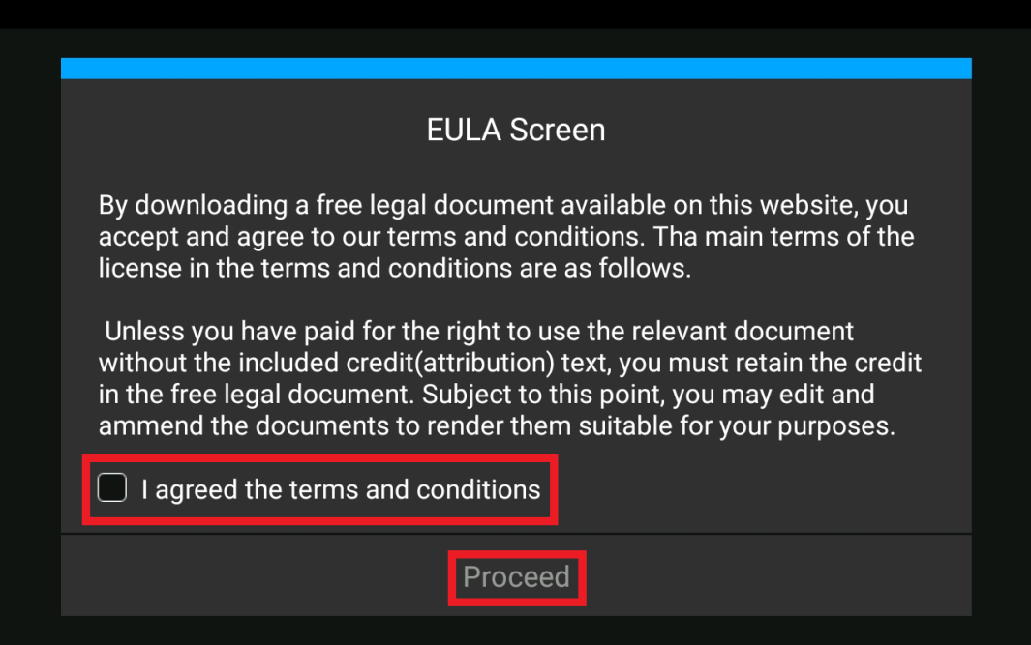

*Fig. 41: EULA Screen*

1. The Admin Pin screen shall be displayed. Just type "1234" in the blank box and click on the "GO" button (See fig. 42).

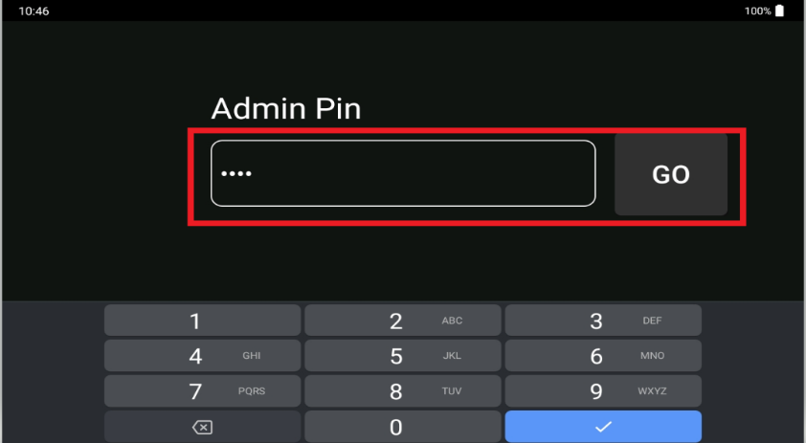

*Fig. 42: Admin Pin Screen*

1. The home screen will be displayed and then click on the connections row to connect to the internet by using either Wi-Fi or LTE Hotspot. Let’s start with Wi-Fi (See Fig. 43).

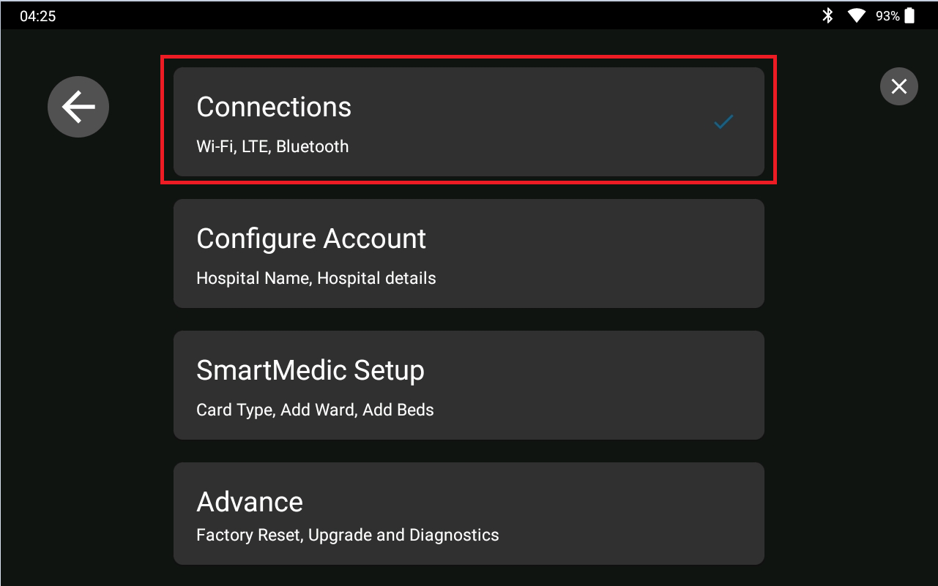

*Fig. 43: Home Screen*

1. The Connections screen will be displayed. Click on the Wi-Fi row and select the hospital Wi-Fi network, followed by entering the password, then click on the connect button (See Fig. 44).

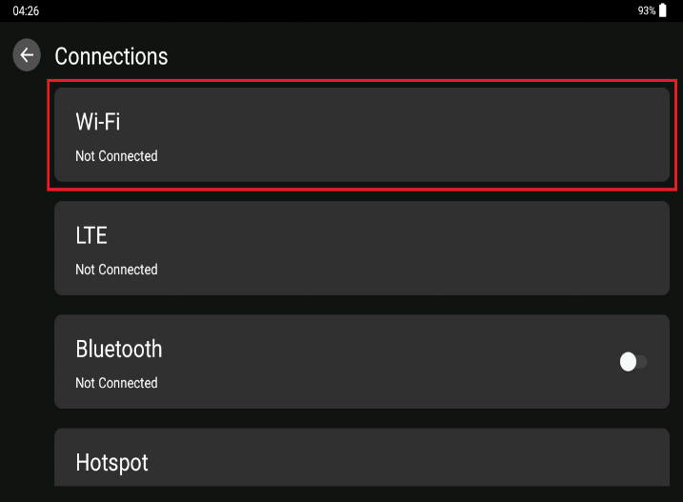 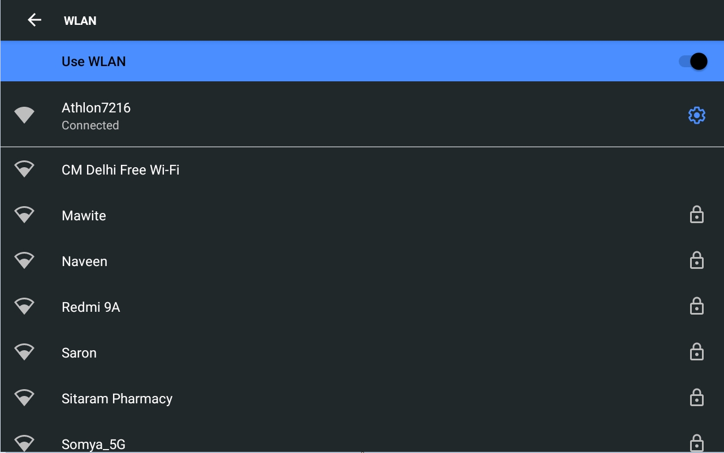

*Fig. 44: Connections Configuration Screen*

OR,

1. If hospital Wi-Fi is not available, start with LTE. Click on the LTE row and turn on the Mobile Data and click on the Hotspot row. Click on the WLAN Hotspot and turn on the Hotspot. (Note: 4G sim should be inserted on the tablet for step no. 7).
2. Turn on the Bluetooth toggle button and click on the back button on the connections screen (See fig. 45).

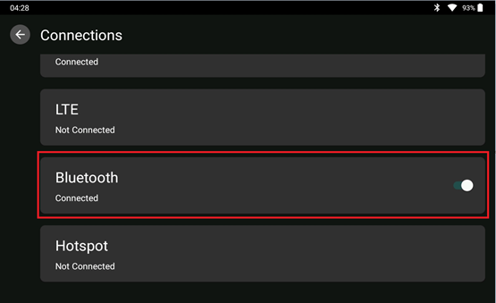

*Fig. 45: Connections Screen*

1. The home screen shall be displayed, and the icons for Wi-Fi and Bluetooth shall be displayed on the top status bar of the tablet screen.
2. Click on the Configure Account row, enter the hospital name and click on the Confirm button (See fig. 46).

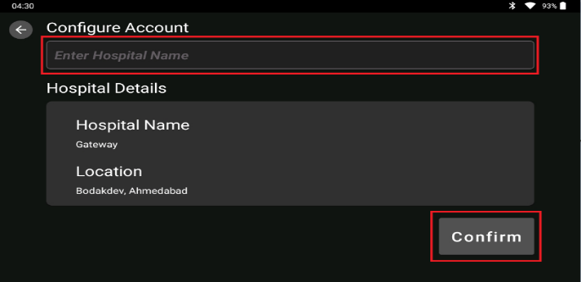

*Fig. 46: Account Configuration Screen*

1. “Hospital account configured successfully” shall be displayed. Click on the back button.
2. Click on the SmartMedic Setup row, enter the ward name, e.g., ICU-00x, and click on the Done button (See fig. 47).

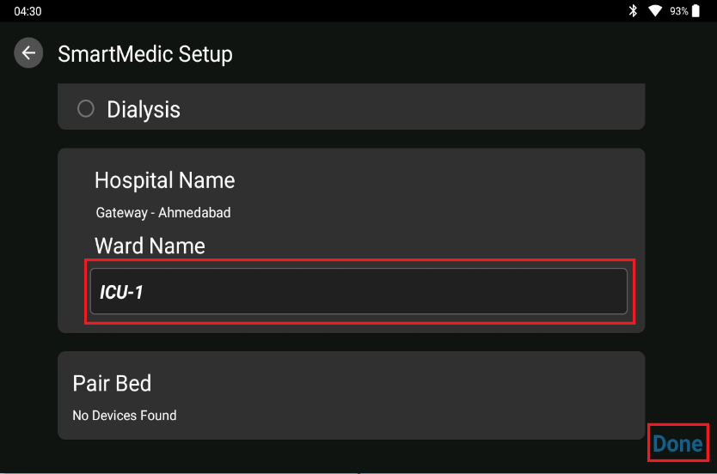

*Fig. 47: SmartMedic Setup Screen*

1. “ICU assigned successfully” shall be displayed. Click on the Pair Bed row on the SmartMedic Screen.
2. The Pair Bed screen shall open and a list of the available SmartMedic devices will be displayed under the Available Devices section (See fig. 48).

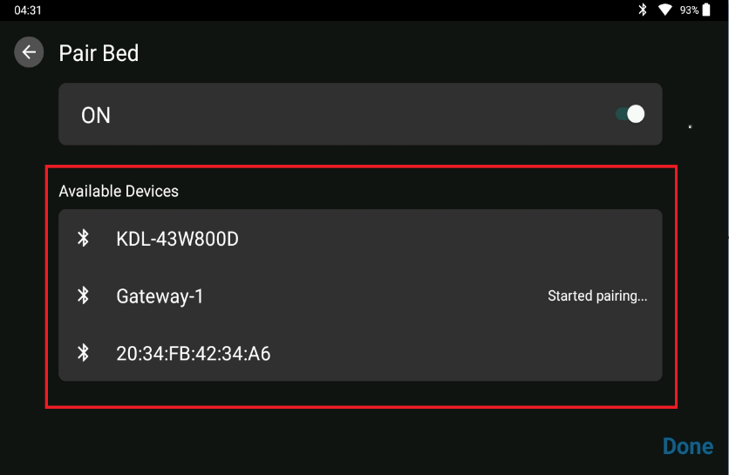

*Fig. 48: Pair Bed Screen*

1. SmartMedic Device: Press any of the SmartMedic device's buttons on the SmartMedic device screen and press Menu. Go to Settings->Diagnostics->Connectivity->Modify (See fig. 49).
2. SmartMedic Device: Random BT Passkey shall be displayed on SmartMedic screen (See fig. 50).

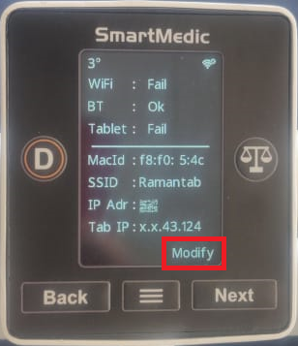

*Fig. 49: SmartMedic Connectivity Status Screen*

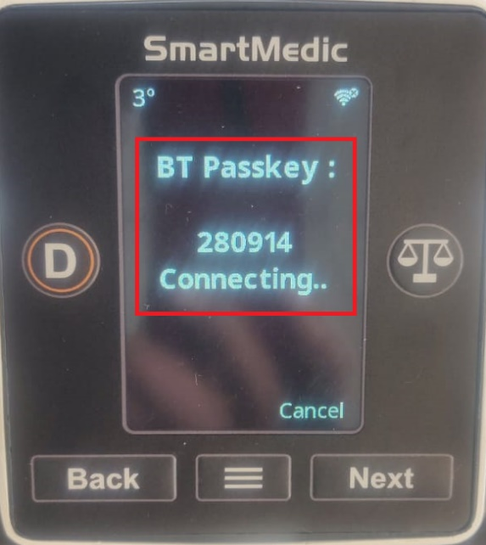

*Fig. 50: Bluetooth Passkey Screen*

1. Select the SmartMedic devices from the list and the "Started Pairing" text will be displayed just beside the SmartMedic device name, and a pop-up will be displayed with "Pair & Connect" and "Cancel" icon. Click on Pair & Connect and now a pop-up will ask for the pair key that user generated on the SmartMedic device. Enter the pair key and click on the OK button on the tablet.
2. “Push Settings” button shall be displayed under the Connected device section. Click on the “Push Settings” button (See fig. 51).

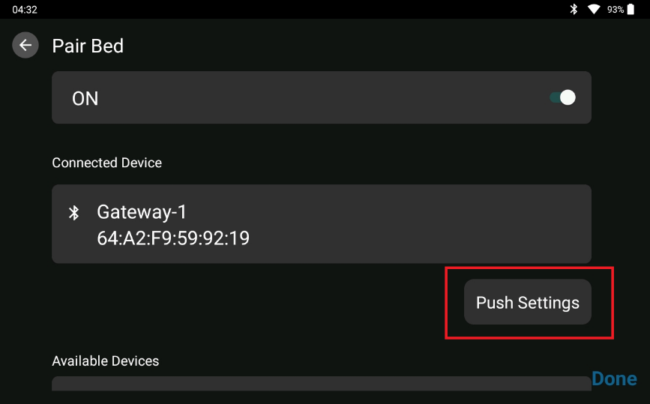

*Fig. 51: Gateway Push Settings Screen*

1. On the SmartMedic device screen, Bluetooth and Wi-Fi icons with the status “Connected” must be displayed.
2. The "Assign Bed Number" blank box shall appear on the Pair Bed screen under the Connected Device section. Select the bed number from the list of available beds and click the "GO" button (See fig. 52).

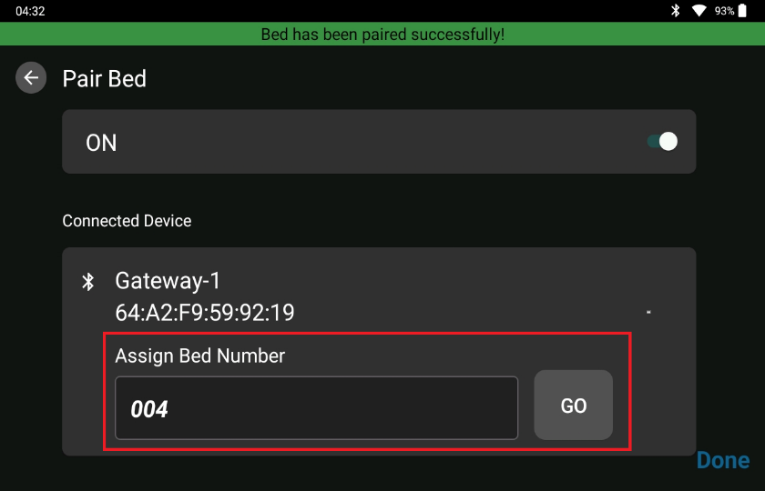

*Fig. 52: Bed Number Assignment Screen*

1. A pop-up "bed has been paired successfully" shall be displayed. Click on the Done button twice.

### 4.8.4 On the Nurse Station Display:

**Step- 1:** On the Nurse Station, open the link <https://smartmedic.stryker.com> in the browser to initiate the setup. Webpage (See fig. 53) will open. Enter the ‘Hospital Code” which was generated in admin app registration.

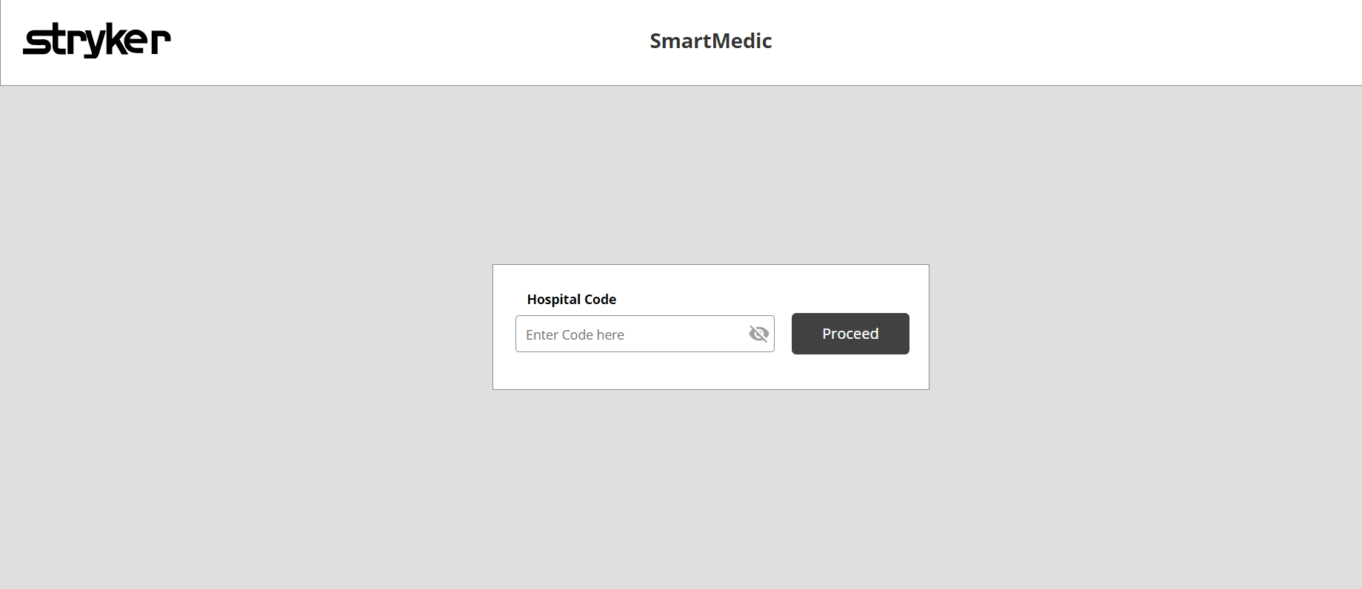

*Fig. 53: Nurse Station Webpage*

**Step- 2:** After entering the “Hospital Code” webpage (See fig. 54) will open. All the ICU names and numbers added in admin app registration must be displayed.

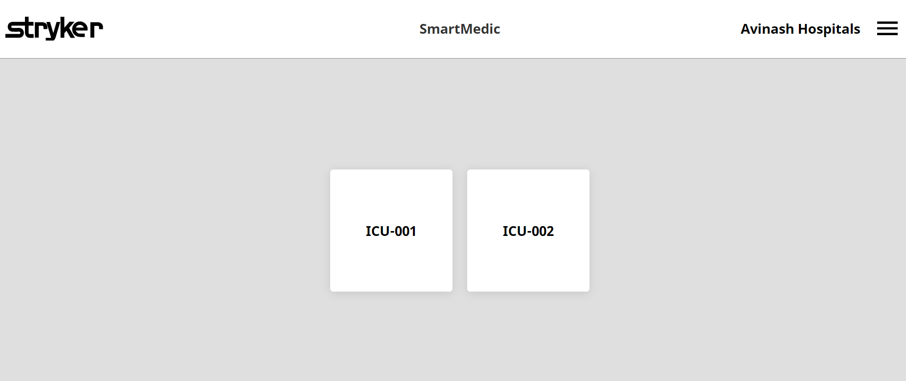

*Fig. 54: ICU Webpage*

**Step- 3:** Installer can now proceed to the bedside display and begin the test run.

# Test run

After setting the complete system, installer needs to perform a test run with the calibrated weights provided in the installation kit [001-02-G-00-00-00] and the reading of the same must be noted in the post installation checklist. Following steps must be performed:

1. Tare the system before initiating the test.
2. Note the initial value displayed on the screen in no loading condition.
3. Keep the 500g (See fig. 55) calibrated weight on the head region and note the reading on the display screen by pressing “Get weight”.



*Fig. 55: Calibrated 500g weight*

1. Similarly, note the readings by placing the weight on the abdomen region, thigh region & foot region.
2. Now randomly place the two 500g weights on the device to note the reading on the display screen.
3. Record all the readings in the post-installation checklist for reference.

# Discard packaging

After completion of the installation procedure, collect all the unpacked covers and plastics from the device packaging and keep them into the main box and then close the box with top cover before leaving the hospital premises.

Minimum litter should be maintained.

# Installation Checklists & Tasks

This section provides information related to the installation checklist and the concerned tasks provided to the installer before handing over the system to the concerned hospital authorities.

Installer needs to fill the ***Installation checklist*** (Annexure I) sheet after installing the SmartMedic system on the hospital bed.

**Tasks:**

1. After installation procedure is completed, handover the **Information for Use** (IFU) Manual to the customer or concerned person.
2. Installation person needs to change the ***Tablet Login Default Password*** before locking the same in Tablet Enclosure.
3. Installer of SmartMedic system will provide training to the Hospital Bio-Med Staff & the concerned nurses and who so ever is engaged in the handling, cleaning etc. of system.
4. Installer must provide training to IT person in the hospital regarding the Issue or Complaint logging screen in case of any difficulty with the use of the system in field.
5. After installation, fill the post installation checklist provided.

# Software Version Upgradation

Software version upgrade if applicable will be done on the field by the Stryker Service Personnel. Details are mentioned in following sections.

## Tablet Application Upgrade

Refer to the following process/steps for ***Tablet Application Upgrade***:

Once the file has been uploaded on the admin panel,

1. Navigate to Settings -> Advance -> Software Upgrade on the Tablet.
2. The Software Upgrade screen will automatically refresh and fetch the latest upgrade available from the server. User can refresh the screen manually, as well as by clicking on the refresh button on the top right corner (See fig. 56).
3. Click on “Update” button in front of “Application Upgrade” section to upgrade the Tablet applications.
4. The tablet will then download the zip file uploaded on the admin panel, extract the APKs and upgrade the available APKs in the Tablet.

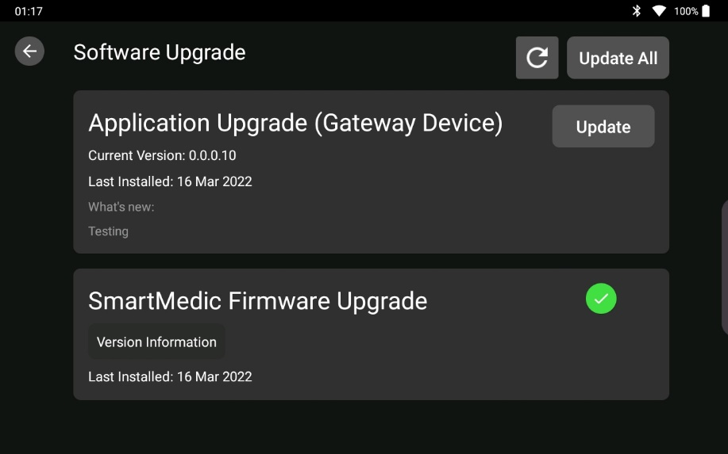

*Fig. 56: Gateway Device Upgrade on Tablet*

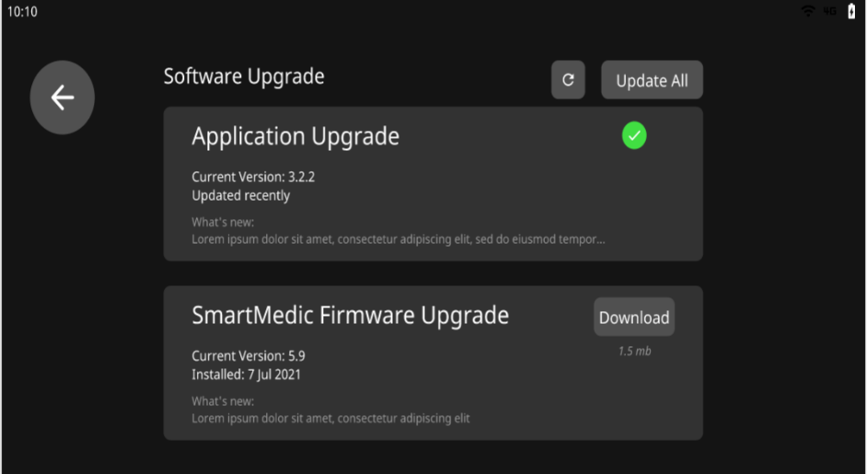

*Fig. 57: Gateway Device Upgrade Success*

## SmartMedic Firmware Upgrade

SmartMedic device firmware upgradation comprises of upgrading the Display and SubCPU firmware. The firmware upgrade will have a combination of Display and SubCPU files when the Tablet receives an upgrade.

Refer to the following process for ***SmartMedic Firmware Upgrade*** on Tablet Application.

Once the file has been uploaded on the admin panel,

1. Navigate to ICU dashboard -> Select the bed which user wants to upgrade on the Tablet.
2. On selecting the bed, bed detail screen is opened having firmware upgrade section.
3. Click on “Update” button in front of display to upgrade the display firmware of the device.
4. After clicking on update button, latest firmware is downloaded from the admin app.
5. The Tablet then calculates the CRC of the downloaded bin file and compares it with the CRC present in the README.md file.
6. If the CRC matches, then the file is transferred to the device else not.
7. The device then flashes the received firmware and reboots.
8. After rebooting, the device sends the updated config packet and the Tablet shows fail/success based on the values received in the config packet.
9. Click on “Update” button in front of subCPU to upgrade the subCPU firmware of the device.
10. After clicking on the update button for subCPU, steps 4-8 are repeated, and status is shown on the Tablet.

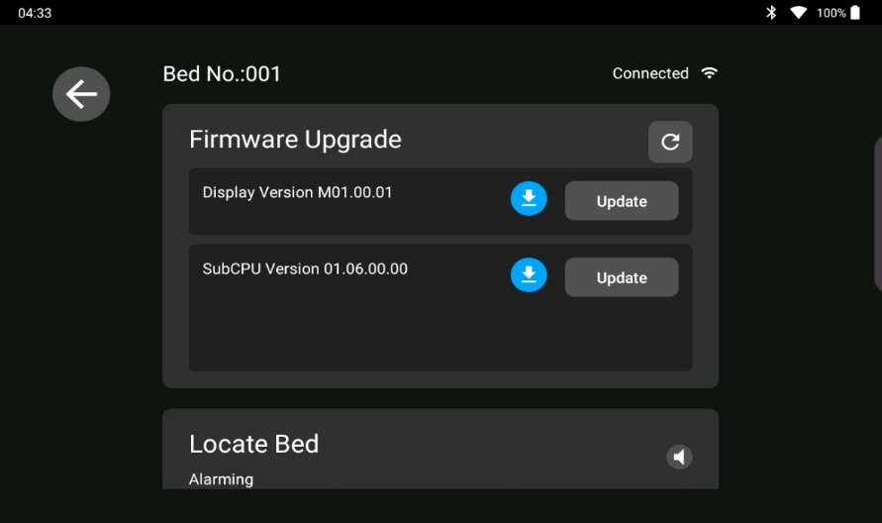

*Fig. 58: Firmware Upgrade on Tablet*

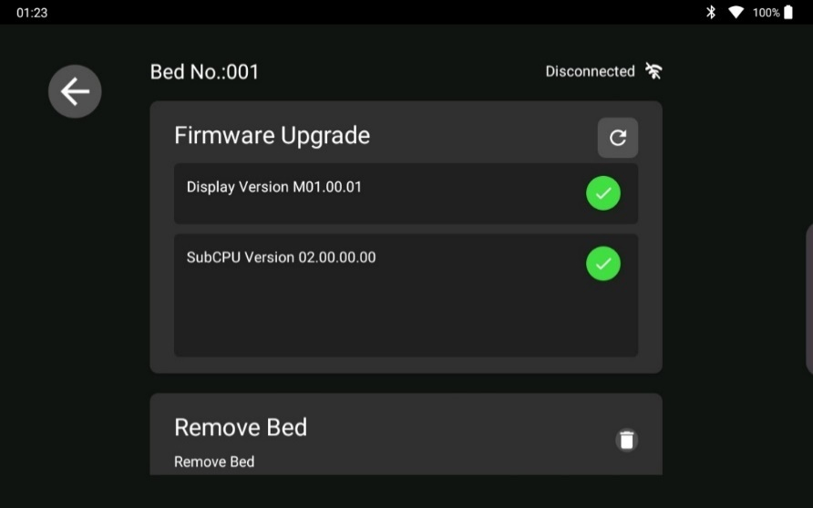

*Fig. 59: Firmware Upgrade Success*

## OTA Package Release

SmartMedic device firmware & Gateway (Tablet) Application will be uploaded over the Admin Application via the following procedure.

**8.3.1. Upload Procedure on Gateway Application:**

1. Prepare a zip file containing the APKs (application packages of the apps) to be upgraded along with a README.md file having the version information of the APKs and Tablet.

*For example:*

README.md file content,

{

"application_version": " 1.8.3"

}

The application version should be greater than the one already present on the admin panel.

1. Login into the NSA admin panel and navigate to Software Upgrade -> Gateway Device section.

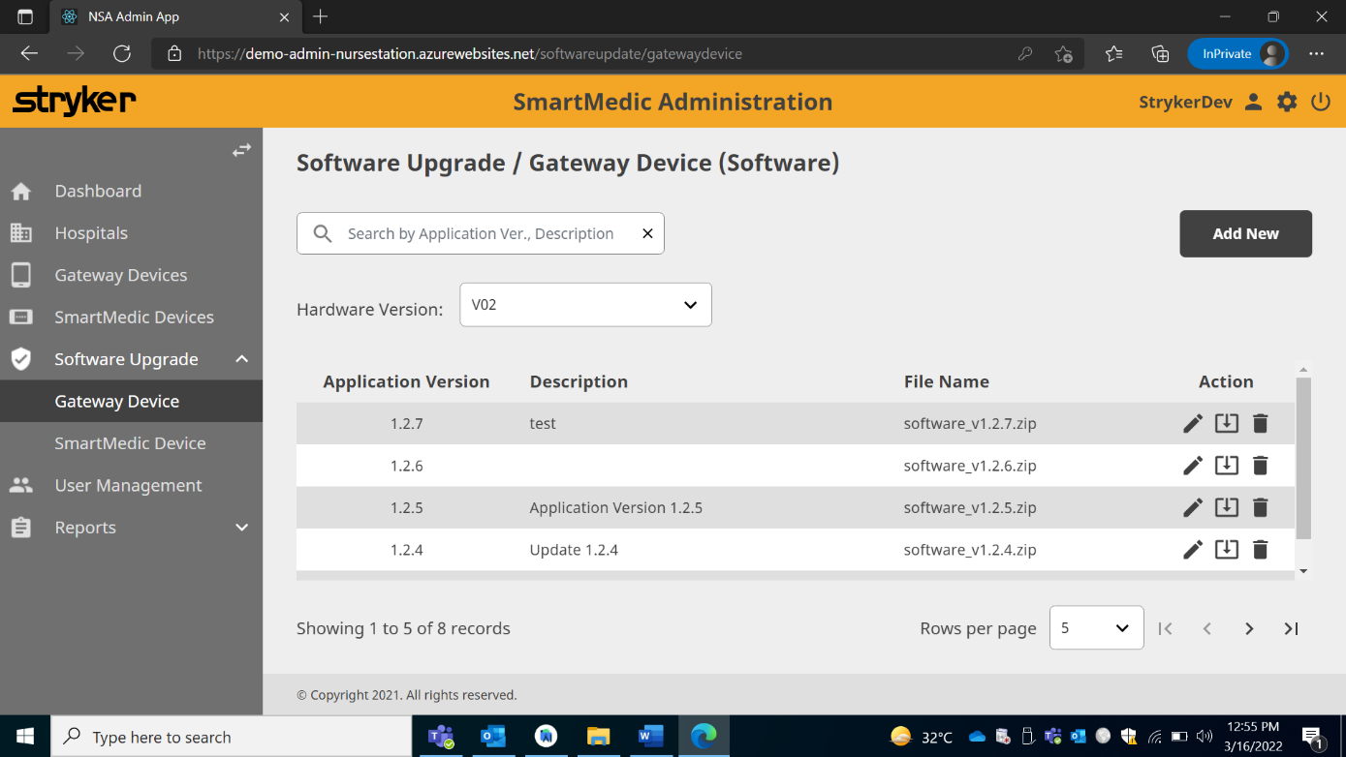

1. Click on “Add New”, to upload the new application version for the Tablet upgrade.
2. Add new opens a popup wizard for uploading the zip file.

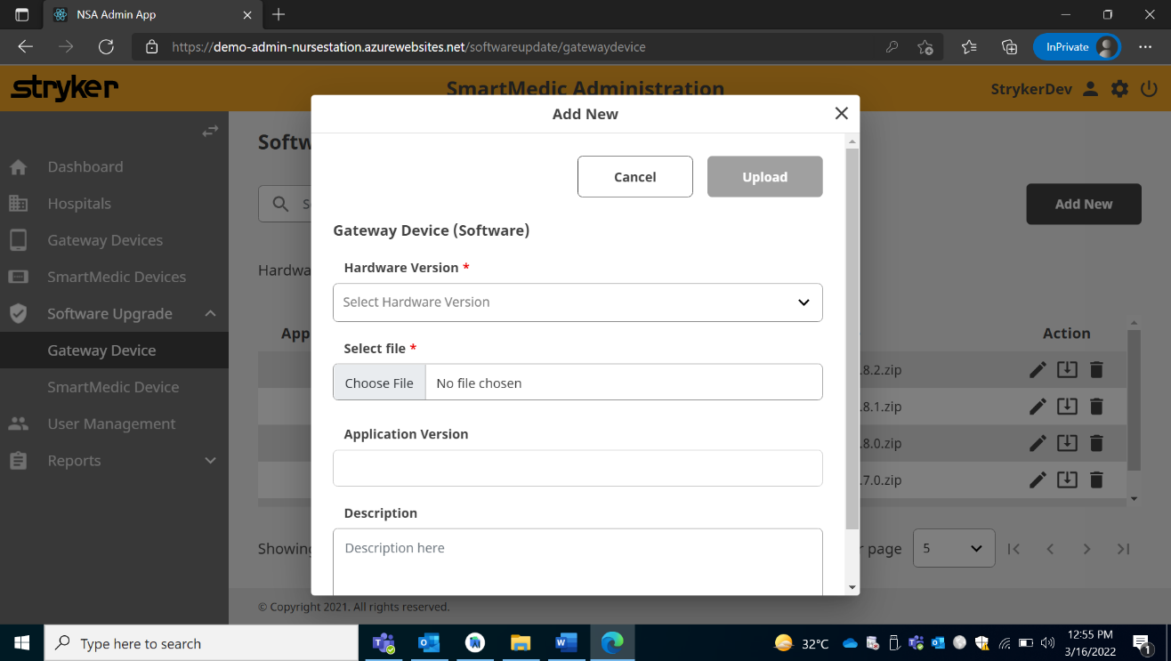

1. Select the hardware version of the Tablet that has to be upgraded.
2. Click on “Choose File” to select the zip file to be uploaded.
3. The Zip file, created in step 1, is then uploaded on the admin panel under the Gateway Devices section.
4. The Application version is automatically filled once the correct zip file is uploaded.
5. Enter description for the upgrade and click upload button to upload the file.

**8.3.2. Upload Procedure on Firmware Application:**

1. Prepare a zip file containing the bin files of Display and Sub-CPU firmware along with a README.md file having the version information of the bin files and device hardware.

*For example:*

README.md file content,

{

"subcpu_version": "3.4.0",

"subcpu_crc":191,

"display_version": "4.4.0",

"display_crc":6,

"hardware_version": "V01"

}

* 1. The display and subCPU versions should be greater than the one already present on the admin panel.
  2. Calculate the CRC of sub-CPU bin file and display bin file separately using CRC Utility and add them in the README.md file in front of respective parameters.
  3. The integer value of CRC must be added in the README.md file and not the hex value.

1. Login into the NSA admin panel and navigate to Software Upgrade -> SmartMedic Device section.

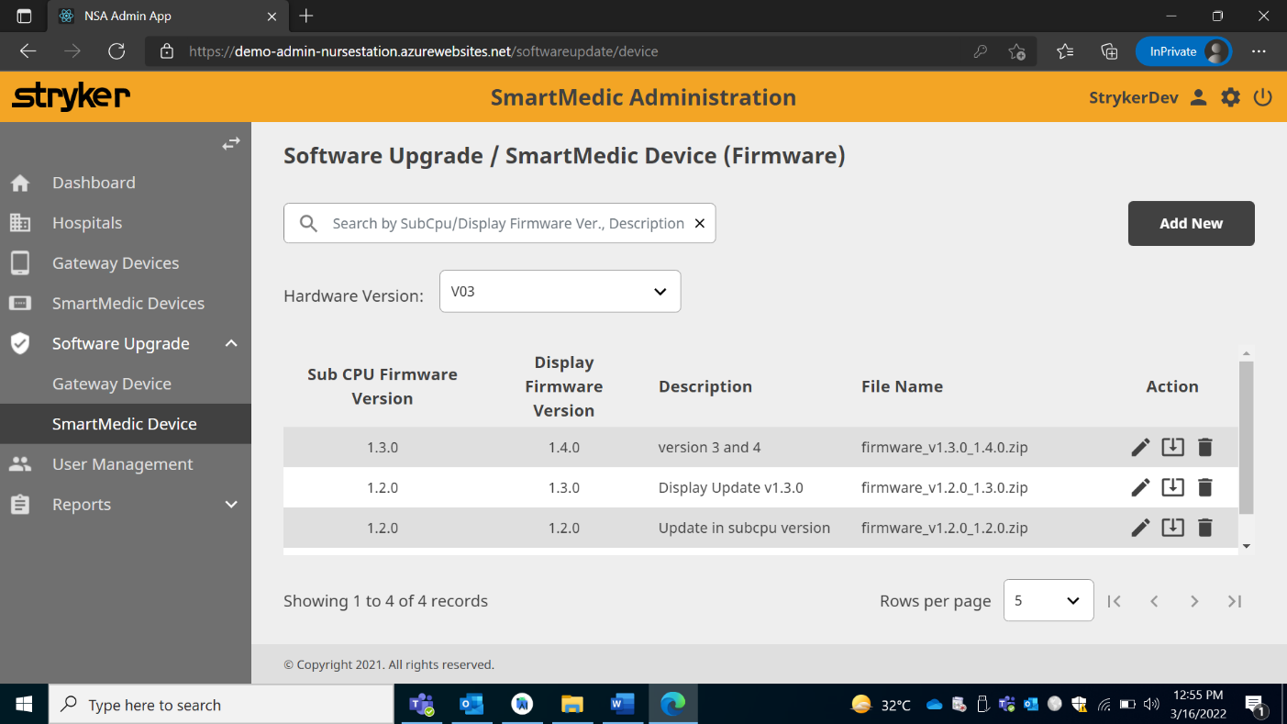

1. Click on “Add New”, to upload the new display and sub-CPU version for the firmware upgrade.
2. Add new opens a popup wizard for uploading the zip file.

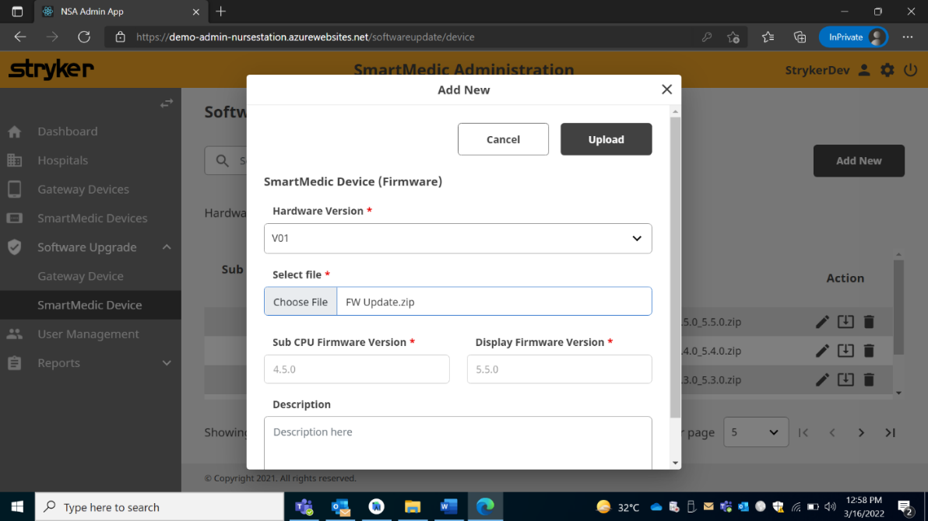

1. The Zip file, created in step 1, is then uploaded on the admin panel under the SmartMedic Devices section.
2. The display and sub-CPU version are automatically filled once the correct zip file is uploaded.
3. Enter description for the upgrade and click upload button to upload the file.

**Annexure – I : Post Installation Checklist**

***Stryker Global Technology Center Pvt. Ltd.***

# Installation & Product replacement Report

|  |  |
| --- | --- |
| ***Name & Address of the Customer:***  *______________________________________________*  *______________________________________________*  *______________________________________________*  *______________________________________________*  ***Tel: __________________________________________***  ***E-mail: _______________________________________***  ***Department****: ___________________________________* | ***Installed by: _____________________________ Installed on: _____________________________ Stryker Invoice No.:***  ***_____________________________ Stryker Invoice Date:***  ***____________________________***  ***Cust. PO No.: ____________________________***  ***P.O. Date****: _______________________________*  ***Hospital Code****: _________________________* |

Equipment installed - As per Installation Manual (D001020092)

**Post market surveillance Plan (Customer Feedback):**

In case of any product failure the nonfunctional parts will be replaced by a new spare **for the period of one year from installation date**.

Refer DDP D001020003 Rev 00 document for details.

**Product Replacement**

The Standard replacement for the product shall be **12 Months (one year)** from the Date ofinstallation report.

*Attach Additional Sheets if necessary:*

* *Received the items in proper working condition as per our purchase order.*
* *Product demonstrated to our satisfaction.*
* *Proper care and maintenance instructions provided.*
* *Product replacement is provided against manufacturing defects only.*
* *It does not cover damages/losses arising out of breakage, mishandling/misuse of items or damages arising out of natural calamities/otherwise.*
* *Product replacement is limited only to repairs/replacement of the items at discretion of the Company.*
* *This Product replacement does not cover consumables.*

|  |  |
| --- | --- |
| *For* ***Stryker Global Technology Center Pvt. Ltd*** | ***Customer*** |
| ***Biomedical / OT Staff*** |
|  |  |
| ***Name, Signature & Stamp*** | ***Name, Signature & Stamp*** |

*No request for Product replacement of the unit(s) claims shall be entertained unless original Installation & Product replacement Report is deposited at the National Service Centre. Alternatively Scan copy can be deposited by e-mail on* ***E-mail: smartmedic@stryker.com***

***(All dispute subject to New Delhi Jurisdiction only)***

***National Centre****: Vatika Business Park, Bock II, 10th Floor, Sector 49, Sohna Road, Gurgaon, Haryana, 122102*

# *Mob No.: 1800 103 8030 E-mail: service.india@stryker.com*

|  |  |  |  |
| --- | --- | --- | --- |
|  | ***Installation Checklist*** | |  |
| ***Sr.No.*** | ***Observations*** | ***Check (✓)*** | ***Remarks*** |
| 1 | *All the components in the packaging are safe and outer skin is not damaged* |  |  |
| 2 | *The part number of components in the package matches with the list provided in Installation Manual* |  |  |
| 3 | *Ensure the count of components in the Package* |  |  |
| 4 | *Device Serial No. on Bed side display shall be verified from the Invoice details.* |  |  |
| 5 | *Installation templates are attached to the plank.* |  |  |
| 6 | *Attach the bed side anchors tightly to the plank bottom.* |  |  |
| 7 | *Use Templates as per the Bed surface mentioned in Installation Manual.* |  |  |
| 8 | *Bed platform is properly cleaned with 3M Primer & 3M Micro-fibre* |  |  |
| 9 | *Peel off the masking tape on 3M 5952 Adhesive Tape without any damage* |  |  |
| 10 | *Apply a slight pressure on the plank after pasting the anchors on the bed surface* |  |  |
| 11 | *Provide a dwell time of 10 min after pasting the anchors on the bed surface* |  |  |
| 12 | *Safely keep all the templates into the kit (as these are reusable)* |  |  |
| 13 | *Ensure the plank is resting on the anchors and no lift off is observed* |  |  |
| 14 | *Bed side display is holding well on the Footboard* |  |  |
| 15 | *All plank to plank cables must be properly attached* |  |  |
| 16 | *Power Adaptor cable must be attached* |  |  |
| 17 | *P2P cables must be routed via strain relief cables and cable holder on the bed* |  |  |
| 18 | *Ensure the Bed side display is Powered ON* |  |  |
| 19 | *Mattress must be constrained into the mattress support without touching the bed components as well as no lift off shall be observed* |  |  |
| 20 | *Optional : For Air Mattress, pump must be properly connected and placed* |  |  |
| 21 | *Web Page on the Nurse Station must be setup as specified in IFU Manual* |  |  |
| 22 | *Bed side display must be setup as per Installation Manual* |  |  |
| 23 | *Test Run* |  |  |
| *23.1* | *Keep the weight and record the results* |  |  |
| *23.2* | *Note the actual weight value and corresponding observed value as table is provided below.* |  |  |
| *24* | *Packaging Discard Process has been followed* |  |  |
| *25* | *IFU shall be handed over to the customer* |  |  |
| *26* | *Latest Software upgrade on the device.* |  |  |

# Test Result Format

|  |  |  |  |
| --- | --- | --- | --- |
| *Sr. No.* | *Actual Weight* | *Observed Weight* | *Remarks / Observed* |
|  |  |  |  |
|  |  |  |  |
|  |  |  |  |
|  |  |  |  |
|  |  |  |  |
|  |  |  |  |

Customer Signature & Stamp Installer Signature

**Annexure – II : New Bed Compatibility Checklist**

**Bed Compatibility Checklist**

|  |  |  |  |  |  |  |
| --- | --- | --- | --- | --- | --- | --- |
| **Section 1: Steps / Procedure to be followed for Bed Compatibility** | | | | | | |
| **Step** | **Checkpoint** | | | **Category** | | **Observations** |
| Step 1 | Evaluate the type of ICU bed on which SmartMedic Needs to be placed | | | Motorized | |  |
| Manual | |  |
| Hinge points for angulation | |  |
| Bed model number | |  |
| Manufacturing Year | |  |
| Step 2 | Look for protrusions and depressions or any other feature on the top of the bed surface platform. | | | - | |  |
| Step-3 | Also note other constraints on the side periphery such as customized integrated mattress supports locations and interference with the SmartMedic system. | | | - | |  |
| Step-4 | Note the Bed platform surface material | | | Metallic | |  |
| Plastic | |  |
| Mica (Wood) | |  |
| Step-5 | Note the dimensions of Bed-SmartMedic combination as depicted in figure 1.  And fill the same in the Table 1 mentioned below. | | | Refer Table 1 and Figure 1 | | Refer Table 1 |
| Step-6 | Physically place the system on the bed surface if all the dimensions are matching the compatibility criterion for SmartMedic with ICU Bed. | | | - | |  |
| Step-7 | Ensure the compatibility by placing Head Plank and Abdomen Plank on the bed surface and angulate the backrest of bed to its max. angle and note that there should not be any interference in both planks. | | | - | |  |
| Step-8 | Similarly check for all the planks by placing it over the bed as mentioned in step-7. | | | - | |  |
| Step-9 | Total length of the system must fulfill the compatibility of Mattress | | | Foam Mattress of size 1880 mm x 830 mm x 120 mm | |  |
| Air Mattress 1880 mm x 800 mm x 178 mm. | |  |
| Step-10 | While evaluating the compatibility, ensure that with mattress supports intact to the SmartMedic , it must not touch any part/accessory of the bed. | | | - | |  |
| **Section 2: Points to be Considered for Installation** | | | | | | |
| **Sr.No.#** | **Check point** | | | **Observations** | | |
| 1 | Always ensure at least 75% of the Bed Side Anchor base surface shall adhere with the bed flat surface. | | |  | | |
| 2 | Position of Bed Side Anchors corresponding to the plank anchors must not have features like holes, projections, surface variations, slots etc.  (Need to check compatibility by placing physical sample) | | |  | | |
| 3 | Perform a basic level test of Accuracy & Repeatability after installation is complete on the Bed. | | |  | | |
| 4 | Perform an Anchoring Test on the Bed surface to ensure the performance of VHB 5952 Adhesive with bed surface. | | |  | | |
| 5 | Perform Plank Strength Test with system installed on the bed to in-line with the strength requirement that are claimed for SmartMedic with bed under study. | | |  | | |
|  | | **Table 1** | | |  | |
|  | | **Dimensions to be measured: (in mm)** | | |  | |
| Reference | | Unit | Permissible Dimension | | Value | |
| a | | mm | 20 to 50 mm | |  | |
| b | | mm | < 750 mm | |  | |
| c | | mm | 50 to 85 mm | |  | |
| d | | mm | < 180 mm | |  | |
| e | | mm | 50 to 85 mm | |  | |
| f | | mm | < 290 mm | |  | |
| g | | mm | 20 to 50 mm | |  | |
| h | | mm | < 440 mm | |  | |
| i | | mm | 20 to 50 mm | |  | |
| L | | mm | 1950 to 2000 mm | |  | |
| j | | mm | For all the supports present on the ICU bed (Need to check  compatibility by placing physical sample) | |  | |
| m | | mm |  | |
| k | | mm |  | |
| Mattress Support Height | | mm |  | |
| X | | mm | more than 800 mm | |  | |
| Z | | mm | more than 45 mm | |  | |

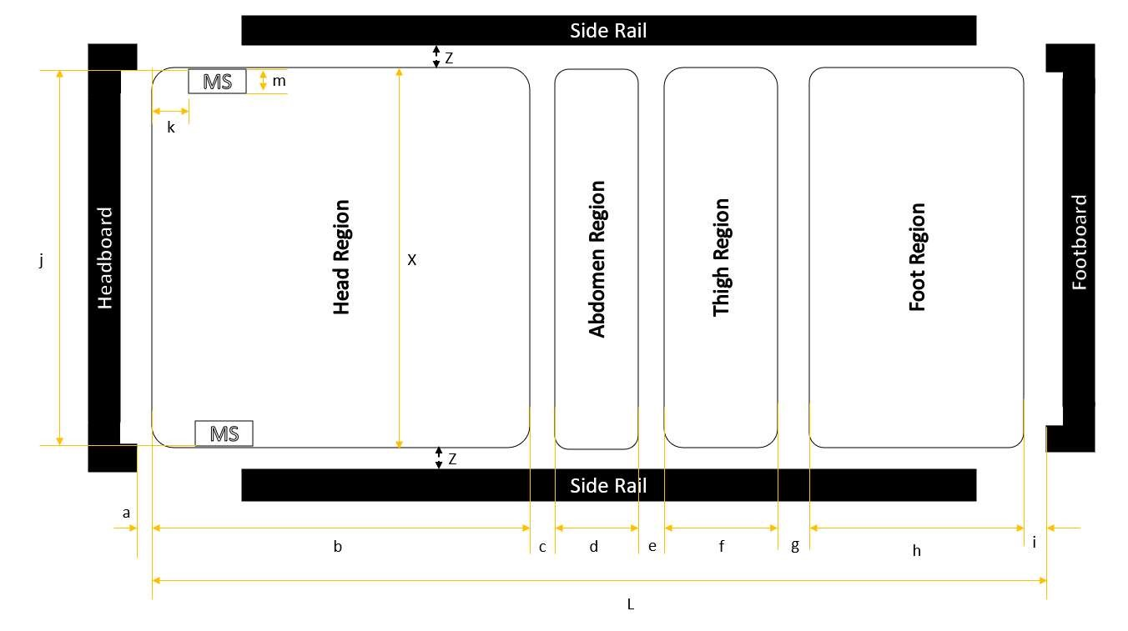

***Figure 1: General ICU Bed Depiction***

**Flow Chart for Bed Compatibility Verification:**

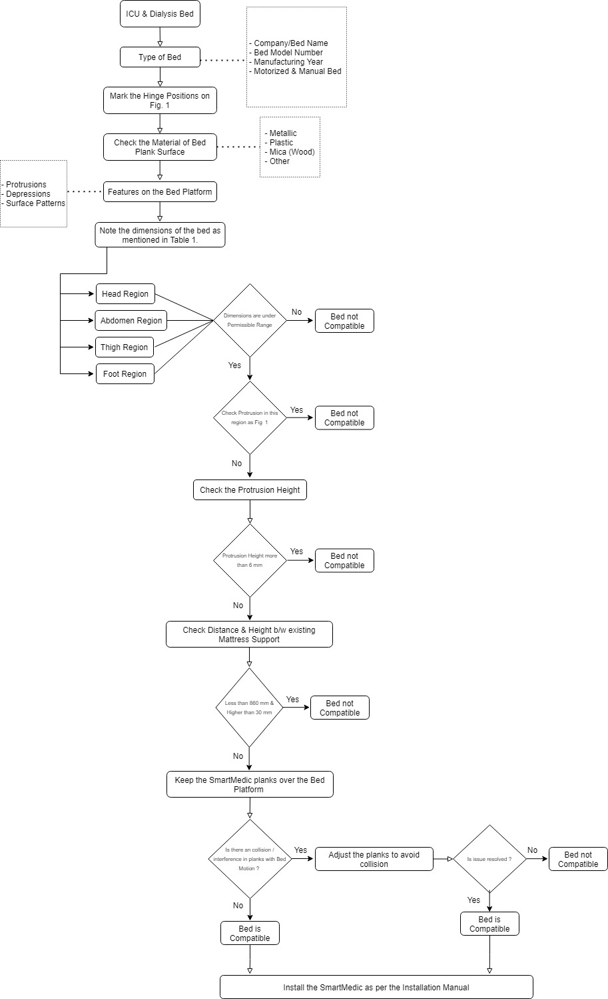

**Revision History**:

|  |  |  |  |
| --- | --- | --- | --- |
| Revision History | | | |
| Revision Level | Description of Revision | Date | Author |
| 00 | Initial Release | 28-Mar-2022 | Ketan Pathak |
|  |  |  |  |
|  |  |  |  |